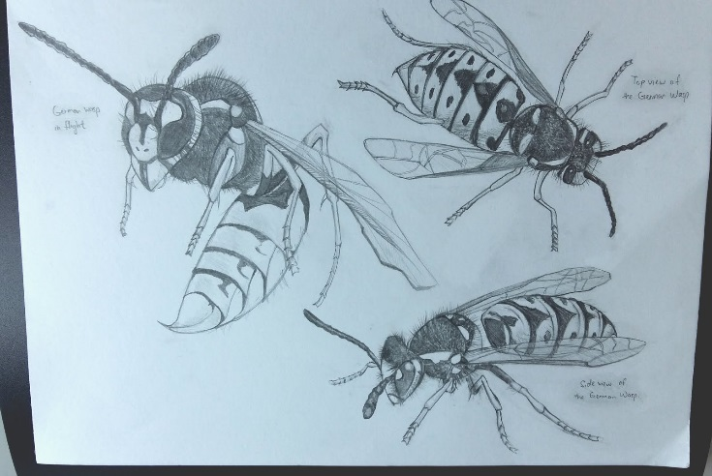[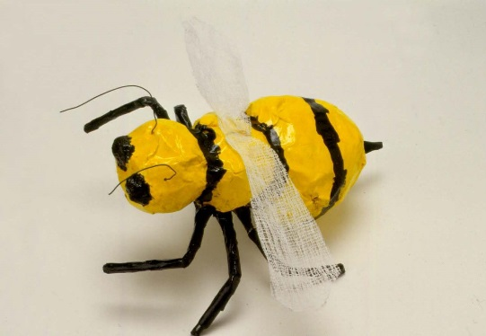](http://www.google.co.uk/url?sa=i&rct=j&q=&esrc=s&frm=1&source=images&cd=&cad=rja&uact=8&ved=0ahUKEwif8c2sjJbVAhWBuRoKHVP5CaMQjRwIBw&url=http://www.artforsmallhands.com/2012/05/papier-mache-bugs.html&psig=AFQjCNEk3Sja5WaV5KM_6NCItIO-ONOi3Q&ust=1500579471838961)[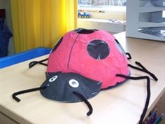](https://www.google.co.uk/url?sa=i&rct=j&q=&esrc=s&frm=1&source=images&cd=&cad=rja&uact=8&ved=0ahUKEwiZxsOYj5bVAhWEOBQKHaG_C-gQjRwIBw&url=https://www.pinterest.com/pin/76913106107550700/&psig=AFQjCNEJvlOAI1ElcbojvZ1apxLXWyNYPg&ust=1500580208009478)[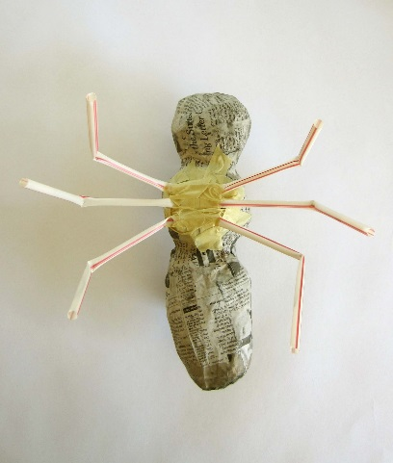](http://www.google.co.uk/url?sa=i&rct=j&q=&esrc=s&frm=1&source=images&cd=&cad=rja&uact=8&ved=0ahUKEwjQ-a3njJbVAhXGOxoKHUV3C14QjRwIBw&url=http://www.artforsmallhands.com/2012/05/papier-mache-bugs.html&psig=AFQjCNEk3Sja5WaV5KM_6NCItIO-ONOi3Q&ust=1500579471838961)[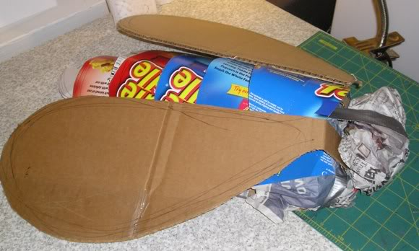](https://www.google.co.uk/url?sa=i&rct=j&q=&esrc=s&frm=1&source=images&cd=&cad=rja&uact=8&ved=0ahUKEwj-iJrPjpbVAhXF1BoKHaCcBuIQjRwIBw&url=https://wormandflowers.wordpress.com/2009/05/02/bugalicious/&psig=AFQjCNEDdS74WpQD-cQ06vnQJLoH6XB8JQ&ust=1500579919394857)[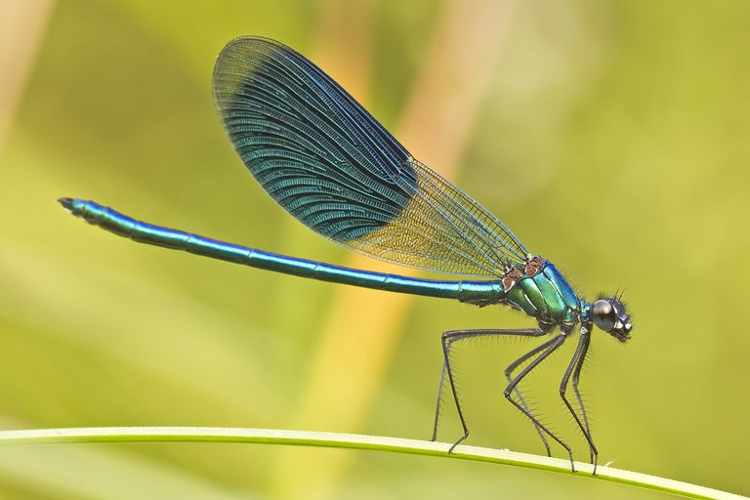](https://www.google.co.uk/url?sa=i&rct=j&q=&esrc=s&frm=1&source=images&cd=&ved=2ahUKEwiErqeUhZTjAhUkz4UKHSb3DcQQjRx6BAgBEAU&url=https://www.thoughtco.com/difference-between-a-dragonfly-and-a-damselfly-1968359&psig=AOvVaw2CPXjbPq5xFjg23DKlMGkS&ust=1562081367510041)

Key vocabulary:

Viewpoints

Observational drawing

Paper mache

Features

Body

Wings

Legs

Attach

Layers

Acrylic paint

construct

**Sculpture**

**minibeasts**