Year 3 Summer Art Knowledge Organiser
Walt recognise and discuss the work of William Morris  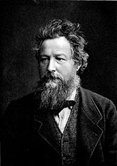  William Morris was born on 24th March, 1834.  He was the son of a wealthy business man.  He originally was going to become a priest but decided to devote his life to art instead.  He became a poet, artist and manufacturer.  He had lots of friends who were writers, poets and artists.  His career in designing started when he decorated his own house in London. | Walt to enlarge a piece of artwork  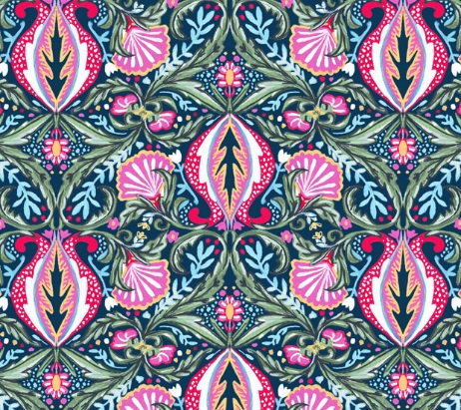  Enlarge – to make bigger  Viewfinder – a device that helps you focus on just a part of a picture  Colour matching – transferring colour from one thing to another.
Walt design our own William Morris inspired printing tile  Using inspiration form the William Morris artwork the children are now going to design their own simple flower/plant inspired pattern (wallpaper).  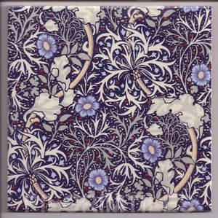  Each child will have a polystyrene tile to draw round it, then create/design their pattern inside, using William Morris as inspiration | Walt mono print  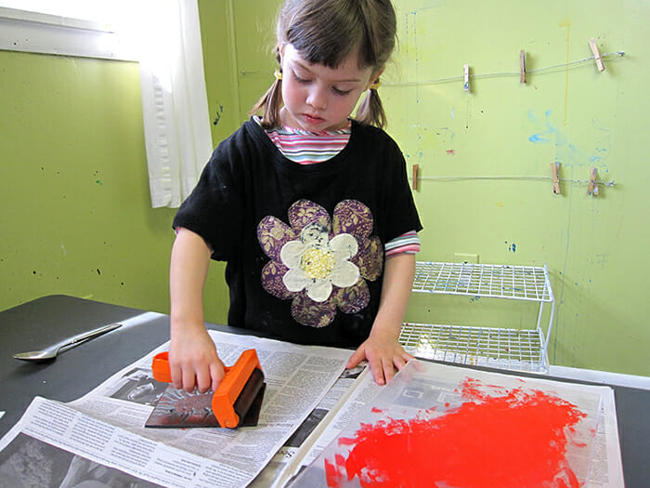  Children need to know how to transfer their design onto a polystyrene tile and then indent the pattern. The children then need to be shown how to ink their tiles and create their patterns.  