Year 4 Summer Art Knowledge Organiser
Walt Look at line in works of art  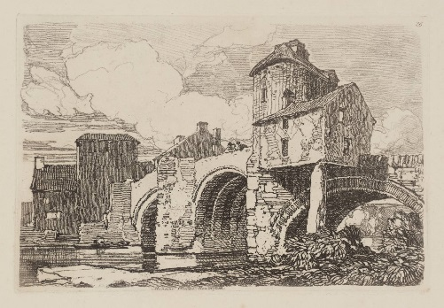  John Sell Cotman was born in Norwich, England, on 16 May 1782 and was educated at the Norwich School. He showed a talent for art from an early age and would often go out on frequent drawing trips into the surrounding countryside. His work can be found in the United Kingdom at the Castle Museum and Art Gallery in Norwich (well over 2000 pieces), Leeds Art Gallery, the Tate Gallery, the British Museum and the Victoria and Albert Museum in London, the Fitzwilliam Museum in Cambridge and other regional centres.  Monnow Bridge – a sketch drawn by John Sell Cotman in 1838. | 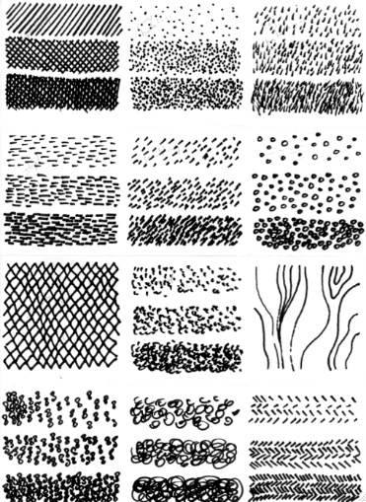  Walt select appropriate mediums to use effectively in our artwork  Experiment with a variety of thick, medium and thin tipped pens to create a variety of lines. Think about how texture and lines can be created.  Line -The use of various marks to create 2D and 3D shapes, they can vary in length, width, direction and shape.
Walt make patterns with line and shape.  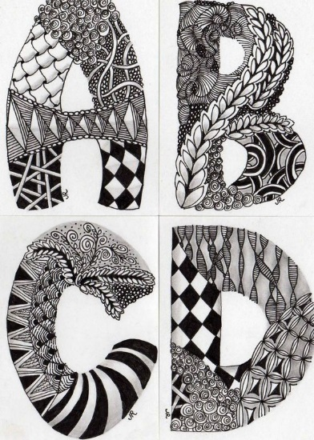  Zentangle is an easy to learn method of creating beautiful images by repeating patterns. It is a new art form that is fun and relaxing. It increases focus and creativity. Zentangle provides artistic satisfaction and an increased sense of personal well being. Zentangle is enjoyed by a wide range of skills and ages and is used in many fields of interest. | Walt to use a variety of techniques to create tone  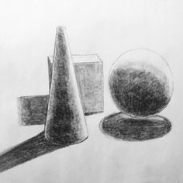  Cross hatching - a technique used to create tone or shade using lines that cross each other at an angle/ Look at the work of Edward Ardizonne who uses cross hatching to create tone – illustrator of ‘Stig of the Dump’.  Tone- the light and dark areas used to make an object look more realistic.  Shading – the darkening or colouring of an illustration which gives it more depth and a 3D look

