**Year 6 Laws Knowledge organiser**

British law is there to keep everyone safe. British law includes civil law (rights and duties of citizens dealing with other citizens) and criminal law (offences against society) You may have your own thoughts on the rules already in place, sanctions for those who break them or have your own set of rules you would like to implement if you were in charge. You may also have your own set of religious laws that guide how you live your life.

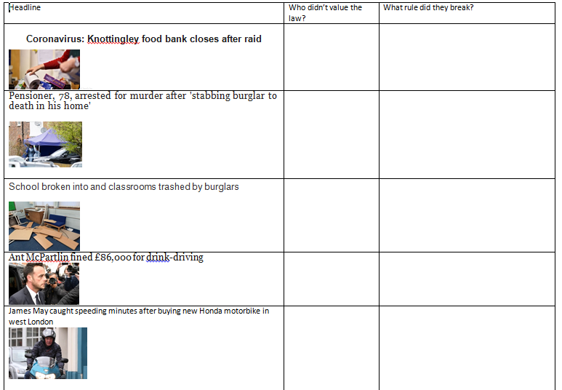 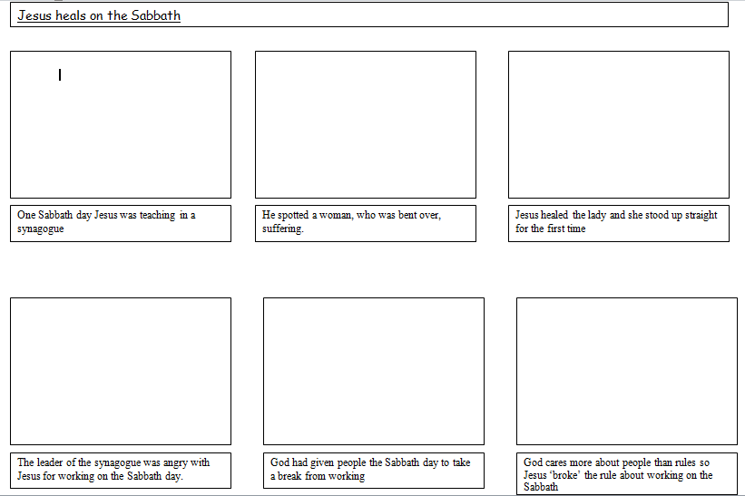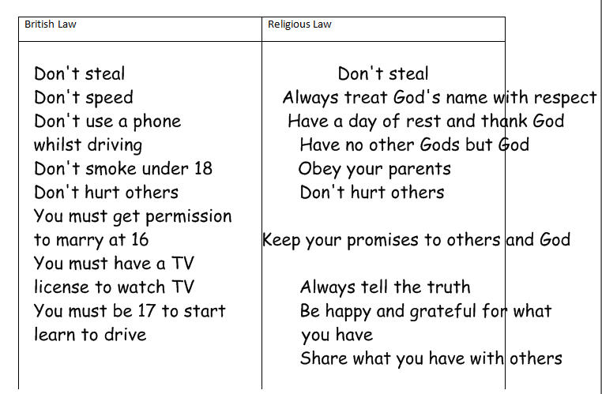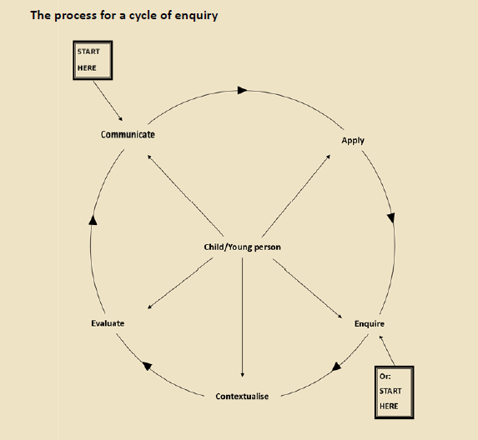

All religious law is important to

Christians because it is a belief

system that guides their way

of life

Don’t speed

property

James

Don’t drink and drive

property

Don’t vandalise other people’s property

Burglars

Ant

Don’t break into someone’s home. Don’t hurt others.

2 men

Don’t steal

4 men

What rule did Jesus break?

He broke the rule of no work on the Sabbath because he healed a lady.

What was the message behind the Sabbath?

Always help someone in need. Rules are important but Jesus knew the needs of the people are more important.

Rule: a set of conditions/ instructions people are expected to follow

British Law: a system of rules that are created and enforced through British social and governmental institutions

Religious law: a system of rules followed by a religious group