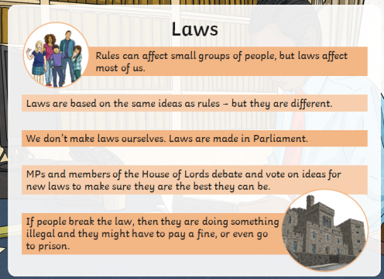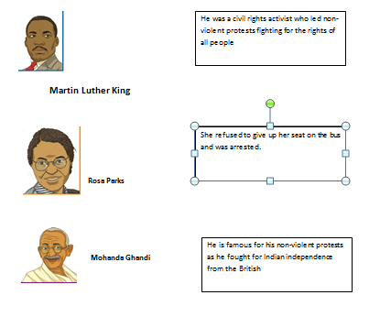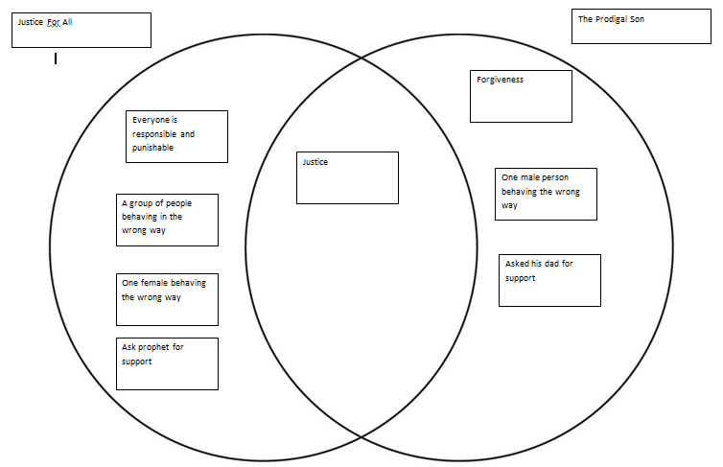

Apply

What does justice mean to others?

Communicate

What does Justice mean to you?

Justice is all to do with fairness but fairness doesn’t always mean being treated exactly the same way.

**Year 5 Justice Knowledge organiser**

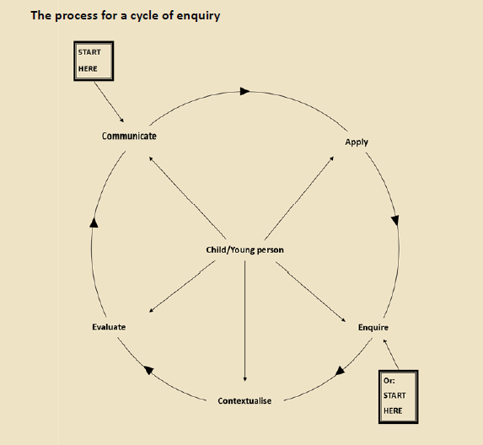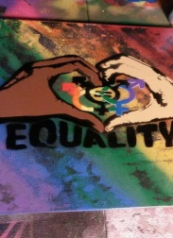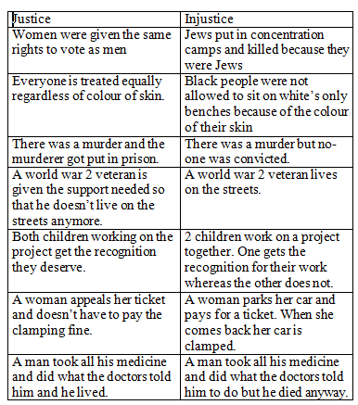

What British law can you think of?

*How is justice important in these 2 stories from different religions? (very important, the Islamic story teaches that justice is for everyone regardless of power, the Christian story teaches* that people should behave responsibly and conserve what they have rather than be reckless, to be respectful and fair then everyone will receive justice. Forgiveness is important when people make mistakes and this can appear like a sense of injustice but God is kinder than humans and recognises when they make mistakes, it wouldn’t be justice if we were genuinely sorry and given the same sanctions as those that were not).

*Do you think justice is important to all religions? Is religious law different to state law? (Yes religious law is all about behaviour, state law will contain other rules too like don’t park on double yellow lines, wait at a red light)*

Justice for All

The key message in this story: everyone should be treated fairly regardless of status.

The Prodigal son

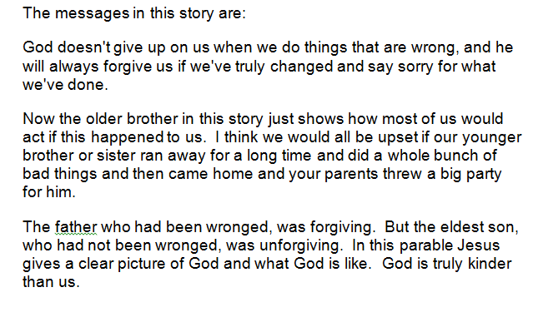

Also people should behave responsibly and conserve what they have rather than be reckless and be respectful and fair.

Justice: fairness