**Year Myth Knowledge organiser**

Communicate and apply

Have any myths influenced you in any way? Did they help you live your life? Have you behaved in a different way because of them? Did they help you to understand anything?

Evaluate: Not important at all: I think the myths are a small part of their faith and they are more likely to follow the scriptures because a myth is an imaginary story so I’m not sure how much truth is in them. Some importance: I think they are a little bit important because there are important messages in them but they can’t just follow the messages and ignore all other parts of the Hindu faith. Very important: The Hindu faith all has one goal- to break the cycle of reincarnation. To do that they have to live their life in a certain way and these messages are taught them through myths so I think myths are very important to Hindus.

Mahabharata Theme: Devotion

Beliefs: Hindus should only be devoted to God and not what they own. They should be kind and help people even strangers. When they are struggling, it can appear that the Gods are being cruel but they have hidden good plans for you. What goes around comes around. If you are kind, people will be kind to you.

Rama and Sita: Theme: Good over Evil

Beliefs: Helping each other, working together to help others for good is powerful, kidnapping is wrong, You can help yourself a bit in times of trouble, keep calm in scary situations, trust the people you know. Don’t be unkind because you are feeling jealous. Man and wife should stick together. True friendship. You should keep your promises. Be honest.

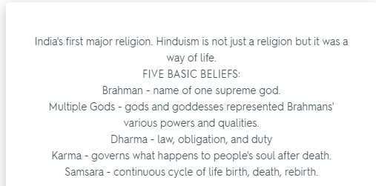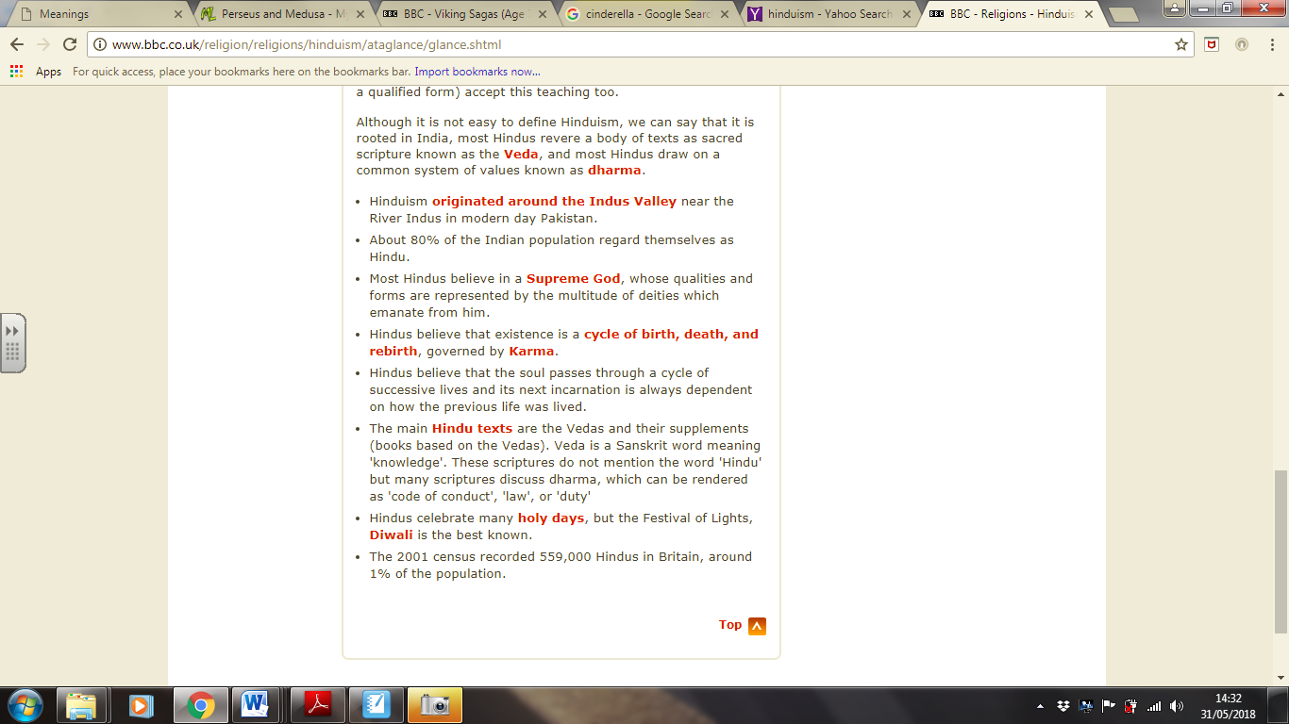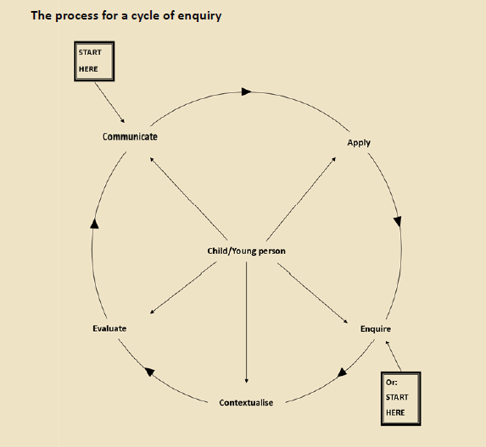

Krishna and the serpent

1. What are the themes of the story (what are the most important things the myth is about? Good overcoming evil)
2. What are the values or beliefs expressed in the myth? (community, helping each other, brotherhood, survival, good will always overcome evil, symbolically: you can lose your way if you forget who you are or are tempted by evil but with support/guidance you will remain on the right path. If you believe in yourself you can achieve anything)
3. Why might the myth be important?

If Hindus believe in reincarnation and it being dependent on how you lived your last life then the myth is very important in teaching Hindus to be good (helping each other, community support) and to make choices that aren’t evil etc

Dharma is religious law about how people should behave themselves (being honest and have compassion)

dharmic path has four aspects: austerity (tap), purity (shauch), compassion (daya) and truthfulness (satya); and adharmic or unrighteous life has three vices: pride (ahankar), contact (sangh), and intoxication (madya)

Myth: Imaginary story to explain life, death, beginning of the world and natural powers

Saga: A heroic story based on truth

Fable: A short story involving animals that talk to humans. Contains a moral for the reader

Folk-Tale: Imaginary stories handed down from generation to generation about hopes and fears

Fairy-Tale: A story about magical imaginary beings and lands