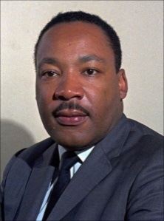**Year 3 Good and Evil Knowledge organiser**

Communicate and apply

What examples of goodness are in your life?

How does it feel when someone has shown kindness?

Dylan Graves saved his friend by pushing him

out of the way of a runaway car and took the

brunt himself.

What does good and evil mean to you?

Why is the festival Holi important to Hindus?

* because they want to celebrate that good over evil
* because it is tradition
* because it is important to celebrate spring and new life
* because Lord Krishna played tricks on people and they worship Lord Krishna
* because they can remember that the God Vishnu has the power to do good.

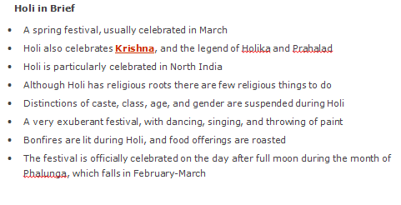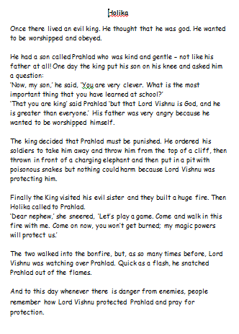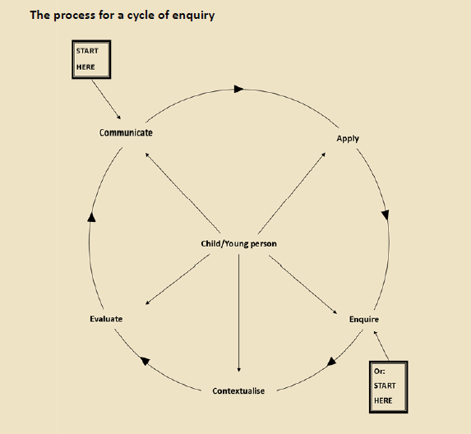

Good: Going out of your way to be kind and spread happiness

Evil: Going out of your way to cause pain and suffering because you enjoy it

Who are the good and bad characters in the story?

Prahlad and Lord Vishnu are the good characters.

The king and Holika are the evil characters.

Hindus celebrate the festival of Holi (similar to Easter and Christmas for Christians) every year and the story of Holiki is the main holi legend. The festival holi is also known as the festival of colours and is a festival that welcomes Spring , celebrates new life and is a celebration of good over evil.