[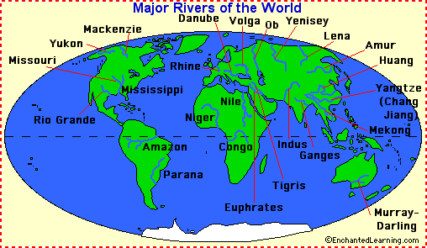](http://www.google.co.uk/url?sa=i&rct=j&q=&esrc=s&source=images&cd=&cad=rja&uact=8&ved=0ahUKEwib0JiXv7DSAhVGrxoKHSlUBDkQjRwIBw&url=http%3A%2F%2Fwww.enchantedlearning.com%2Fgeography%2Frivers%2Fmajorrivers.shtml&psig=AFQjCNE12ZnnyTTc2jSz6OnQFLReilqKeQ&ust=1488292344615507)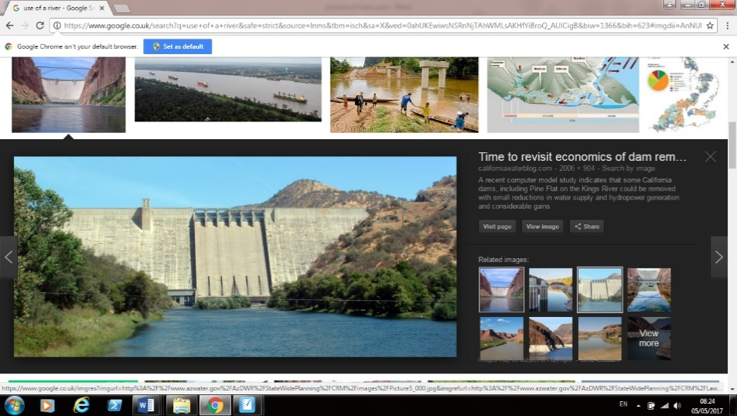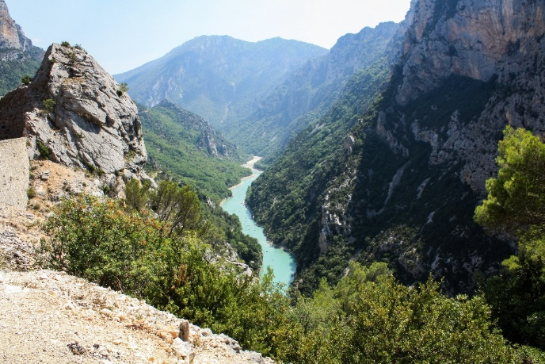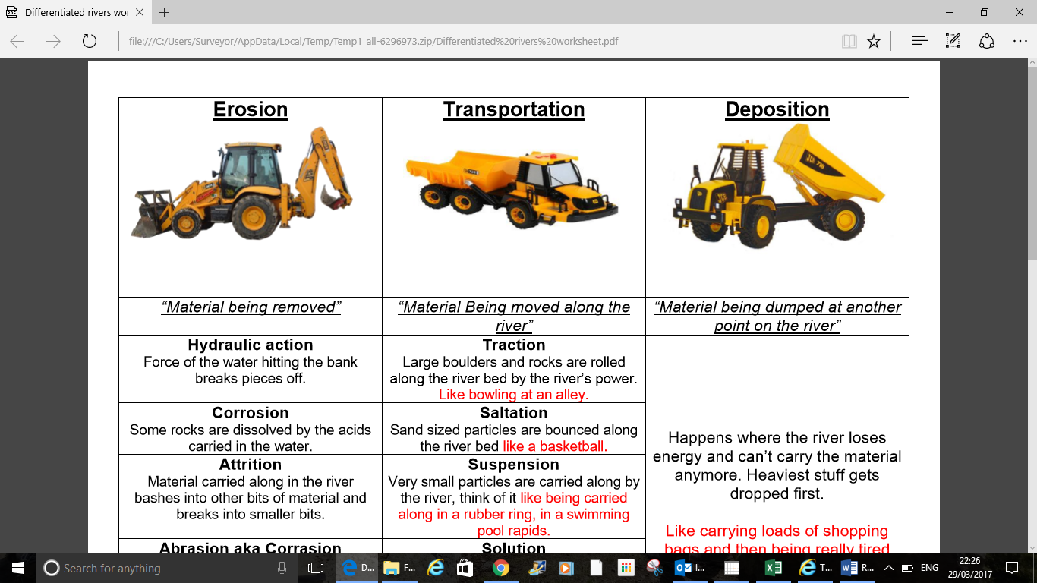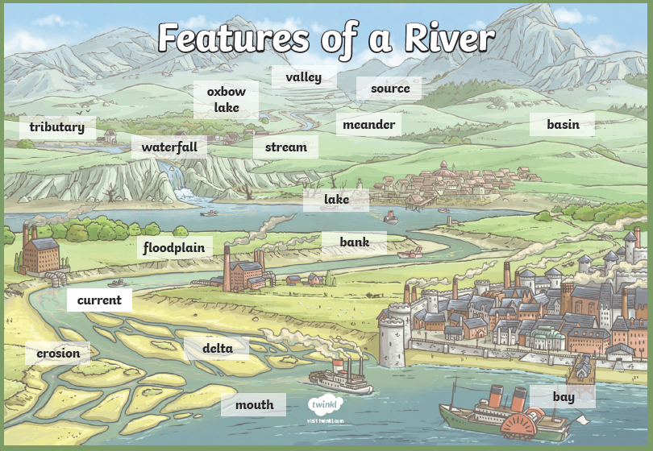

Estuary - the tidal mouth of a large river, where the tide (sea) meets the stream.

Dam - a barrier constructed to hold back water and raise its level, forming a reservoir used to generate electricity or as a water supply.

Confluence – the point where two rivers meet.

Raging Rivers