Step 1 – WALT play and strum the chord of C.  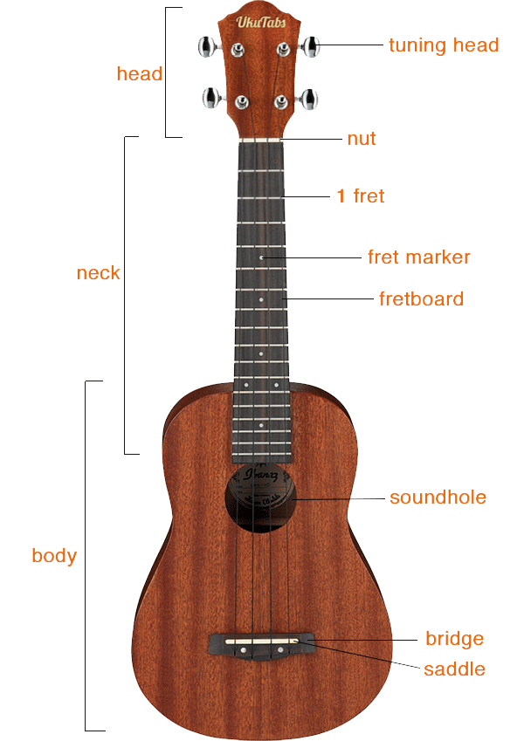  What is a chord?  A chord is a collection of notes that are played at the same time.  The chord of C is created by playing the notes of C, E and G together.  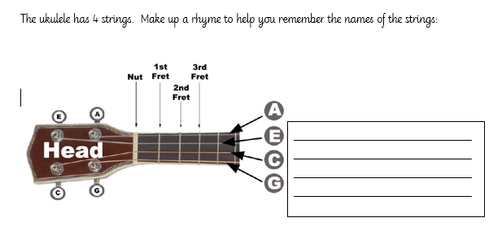  These are the notes of the top 3 strings of the ukulele.  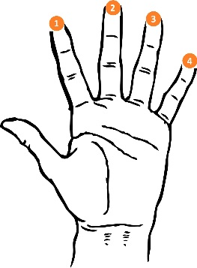  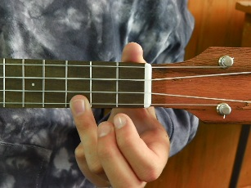 |  | Step 2 WALT play and strum the chord of C and F major  Basic strum pattern:  D – D – D – D – D  (down – down – down – down)  More challenging strum pattern:  D – D – D – U – D  (down, down, down, up, down)
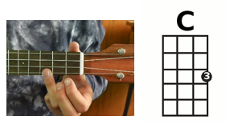  Step 3 WALT play and strum the chord of C F and G7 major  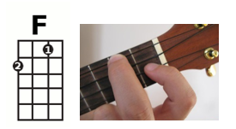  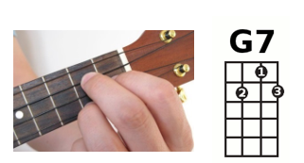 | Step 4 - WALT perform to a live audience. | Henry Purcell (c. 1659 – 1695  Abdelazer – Rondeau  https://www.bbc.co.uk/programmes/articles/16ndky0F6hMWvJ3Xcbc44Dq/abdelazer-rondeau-by-henry-purcell.  How fast or slow is the music? What is the tempo?  How loud or quiet is the music? What is the dynamic?  What instruments can you hear being played?  What images are created in your mind when you listen to the music?

