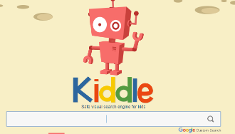  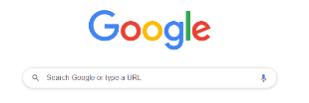  Search engines help you to search the internet for facts, information, videos and photos. Almost anything you want. It is important to know about and use child friendly search engines as this limits the search results to more appropriate viewings for children. | Relevant or irrelevant?  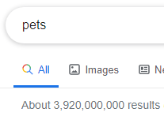  When you search for something you may have MILLIONS of results and you want to find the most relevant. The results will be ordered and prioritised depending on what you typed into the search engine with the most relevant result at the top.  Look out for ads! These are not useful and will take you to an advert about what you searched for- NOT information. | Key information  When you are searching online you need to be careful what you type into the search engine. You need to be specific and make sure your spelling is correct.  I want to know what is the best pet for a child. Here are some of my searches and look closely at the number of results.  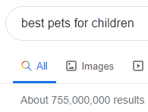
Bookmark webpages  When you find a webpage that you want to keep coming back to you can create a bookmark. This is a quick and easy way to save that webpage for you to reopen when you want to find it. | Using information from the internet  Would you steal a bike and say that it is yours?  Would you steal someone’s book and say that it is yours?  NO.  The same rules apply when you are using the internet. When you find information and want to use those facts in your work that is ok BUT you must say where you got that information from. You are not allowed to copy a section of text, put it in your work and then say you did it. That is called PLAGIARISM. Plagiarism is the same as stealing. | Key vocabulary  Search engine, web browser, online/offline, images, safe searching, plagiarism, citation, appropriate

