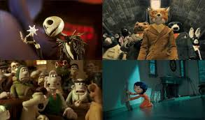  What do all of these films have in common?  They use a technique called stop motion. Stop motion is where you take lots of photographs of figurines and move them slightly after each photo- then, when you play all of the photos after each other it creates a moving animation. | Challenges with stop motion animation  This unit will put to the test your creativity, ambition and most of all resilience.  You will need to have a steady hand to take still and quality photographs.  It will take a lot of patience as you need to make very slight and small movements and changes in your characters between each photo. This will take a lot of time.  You will need to take LOTS of single photos before organising them into a smooth transition. | 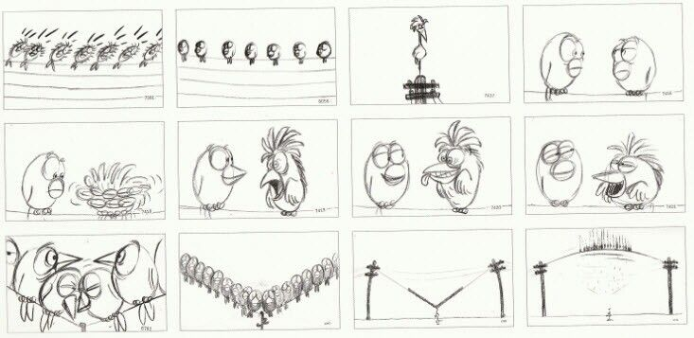  Story board planning  Before any film director starts filming, they need to plan their animation. This is done by creating a story board. A story board using simple drawings to capture the main movements and sequence of the animation. A story board is likely to change many times as the film is being produced as you will make adaptions and improvements along the way.
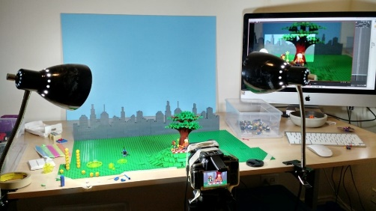  What you will need:  Every animator has a range of equipment. You will need; a background for your scene, characters, good lighting, a good space, a camera and a steady hand! | What you do:  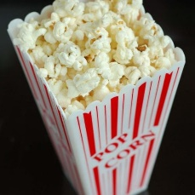  Once you have taken all of the pictures (frames) of your moving characters you will need to export them to a program called qStopMotion. It is here at this point you will be able to edit and remove your frames. This will also be the opportunity to add recorded sound over the top of your animation.  Once you have completed that you need to export your media into your files and prepare for a movie night! |  | Key Vocabulary  Stop- motion animation frame storyboard  digital camera export backdrop scenery

