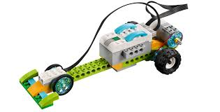  For this unit, you will be constructing your very own race car. You will be connecting this car to a computer program via Bluetooth. You will need to plan your algorithm and debug any errors in your code to enable your car to move. | The Lego Smart hub is a tiny computer that can do a few specific things like control a motor or read a sensor. It connects to a computer wirelessly using Bluetooth and this allows data to go back and forward through the air.  This symbol lets you know a device has Bluetooth. Bluetooth devices need to be paired in order to exchange data | You are very familiar with scratch and have used this program a lot. Now you will be using scratch to control your race car.  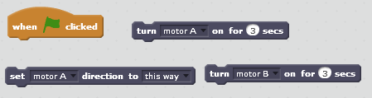  First you will learn how to make your vehicle move forward and stop. It is a race to the finish line so who’s car will be the quickest?
You have mastered controlling your vehicle in a straight line, it is now time to code your car to turn by using the correct algorithms. This will take a lot of trial and error. Be resilient and debug errors in your code.  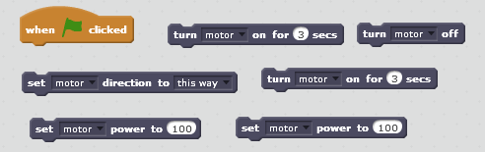 | Are you ready for a challenge?  Draw your own circuit and program your car to follow the track! Good luck.  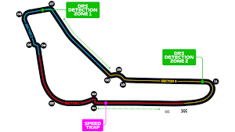 | Key Vocabulary  Debug programming algorithm control systems input output logical reasoning code micro-controller Bluetooth wireless communication hardware software

