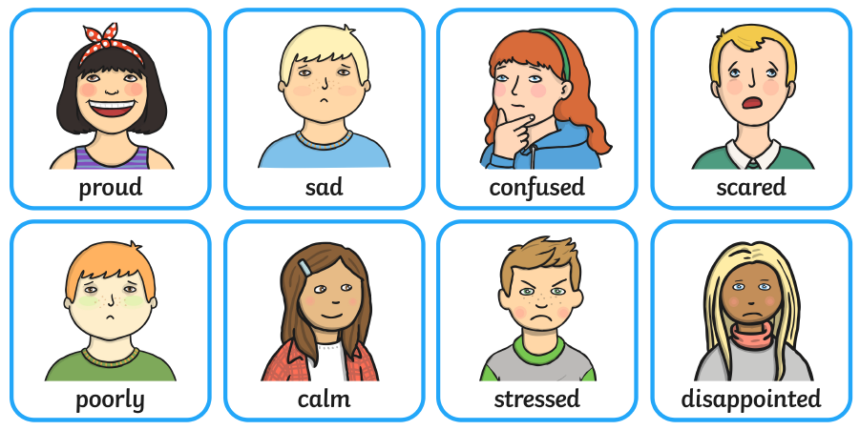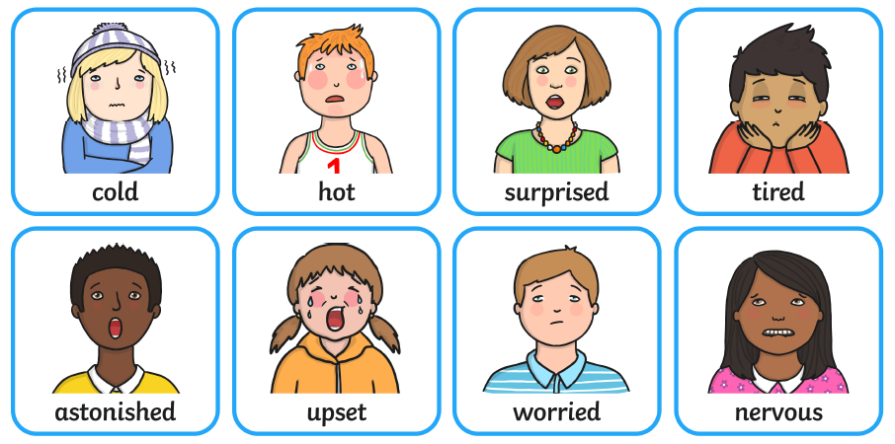
Feelings can range from low intensity to high intensity.
HIGH INTENSITY LOW INTENSITY

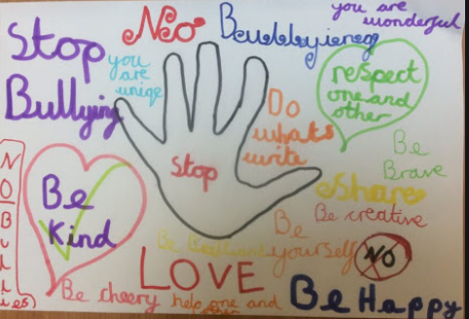
Vocabulary
Loneliness, isolation, wellbeing, bullying, mental, emotional, anger, content, overjoyed, ecstatic, melancholy, achieve, intensity

