WALT 1: understand what positively and negatively affects their physical, mental and emotional health. | WALT 2: understand the impact of bullying on our mental health and wellbeing
WALT 3: know where to go for support for improving mental wellbeing  1.To know how and where to seek support for mental health issues and recognising triggers.  2. I know problems can be resolved if the right support is made available, especially if it is accessed earlier enough.  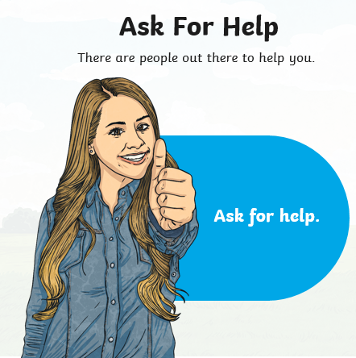 | 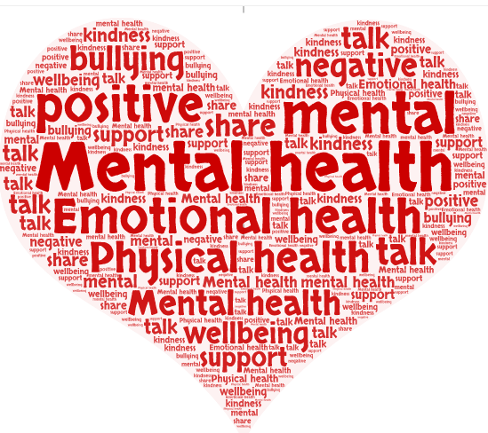  Vocabulary and Reading:  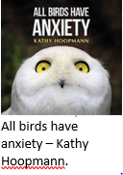  All Birds Have Anxiety uses colourful images and astute explanations to explore with gentle humour what it means to live with anxiety day-to-day, and how to begin to deal with it.

