Year 4 Spanish Knowledge Map – Weather and bullfighting
Step 1  Understand and say everyday weather phrases in Spanish.  Step 2  Read and say the weather in Spanish. | Step 3  Write and say the weather in Spanish.  Recap days of the week and months of the year  Days of the week Months of the year
Step 4  To know about bull fighting and the arguments for and against it.  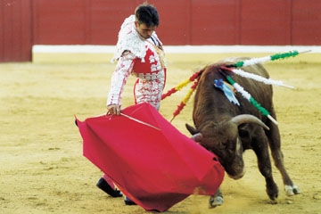 | Step 5  Know about the Spanish festival ‘The running of the bulls’.

