The main and key skill is to become efficient at typing. Here are a few links to take you to some different games to practise.  https://www.dancemattypingguide.com/  https://www.speedtypingonline.com/games/type-the-alphabet.php  https://www.ducksters.com/games/typingtest.php | Inserting a table  We are building on from the skills we learnt in year 3. To make an effective word document there are many different things you can insert. Firstly, we will start with a table. Once you have chosen the size of your table there are many different options when you select the design tab. 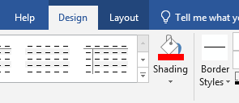 | Inserting and formatting shapes  Finding and inserting different shapes is the easy part. To build on this from year 3, you will be learning to format them to fit in different ways in your document. When you select the format icon there are many different settings to explore. 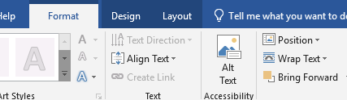
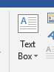  Insert arrows and text boxes  or even the style  You can change the colour and size  A text box allows you to add a box of text anywhere on your page. | Check your spelling and grammar  Finally- all good pieces of work have corrected spellings and grammar.  You will learn to use the tools available to help you check  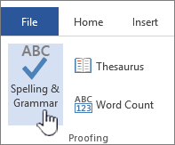 | Key vocabulary  Cell column row format table border diagram insert word processor grammar

