Year 4 Maths Revision Lesson
18.2.22
Step 1: Place Value
1) Write the value of the underlined digits:
a) 567 b) 845 c) 423 d) 3589 e) 7321 f) 9745

2) What is 10 more and 10 less than these numbers?
10 less |  | 10 more
 | 460
 | 732
 | 6354
 | 8797

3) What is 100 more and 100 less than these numbers?
100 less |  | 100 more
 | 745
 | 469
 | 6743
 | 6346

Step 2: Written methods for addition and subtraction.
Use the written methods for addition and subtraction to find the answers to these questions.
1) 4 5 6 2) 673 + 328 = 3) 8356 + 2147 = 4) 7352 + 3455 =
+ 3 4

5) 674 – 322 = 6) 7856 – 3427 = 7) 8465 – 3275 = 8) 4673 – 2394 =

Step 3: Rounding
Round these numbers to the nearest 10.
1) 576 |  | 4) 4,355
2) 342 |  | 5) 5,712
3) 764 |  | 6) 1,344
Round these numbers to the nearest 100.
1) 5,645 |  | 4) 2,142
2) 2,792 |  | 5) 8,815
3) 8,961 |  | 6) 1,977

Step 4: Perimeter What is the perimeter of these shapes?

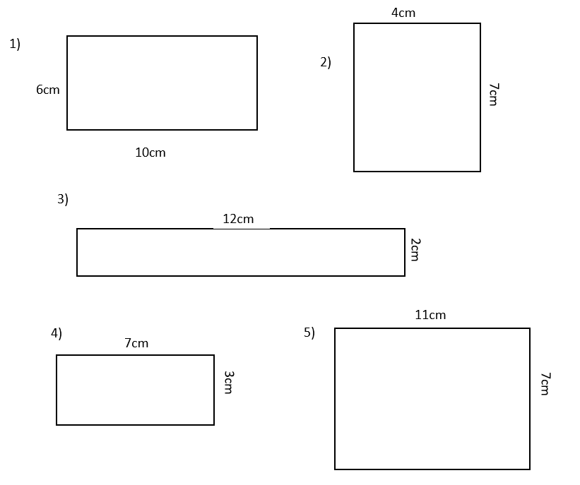
Step 5: Written methods for multiplication.
Use the compact or expanded written method for multiplication to find the answer to these questions (use the method that you are using in your Maths lessons at the moment). If you would like to do more than your colour group, you can!

Purple group:
a) 15 x 4 = b) 21 x 3 = c) 362 x 2 = d) 534 x 4 =

Red/Green group:
a) 354 x 6 = b) 347 x 3 = c) 653 x 7 = e) 425 x 7 =

Year 4 Maths Revision Lesson
ANSWERS
Step 1: Place Value
1) Write the value of the underlined digits:
a) 567 b) 845 c) 423 d) 3589 e) 7321 f) 9745
7 40 400 80 300 9000

2) What is 10 more and 10 less than these numbers?
10 less |  | 10 more
450 | 460 | 470
722 | 732 | 742
6344 | 6354 | 6364
8787 | 8797 | 8807

3) What is 100 more and 100 less than these numbers?
100 less |  | 100 more
645 | 745 | 845
369 | 469 | 569
6643 | 6743 | 6843
6246 | 6346 | 6446

Step 2: Written methods for addition and subtraction.
Use the written methods for addition and subtraction to find the answers to these questions.
1) 4 5 6 2) 673 + 328 = 1001 3) 8356 + 2147 = 10,503 4) 7352 + 3455 = 10,807
+ 3 4
4 9 0
1
5) 674 – 322 = 352 6) 7856 – 3427 = 4429 7) 8465 – 3275 =5190 8) 4673 – 2394 = 2279

Step 3: Rounding
Round these numbers to the nearest 10.
1) 576 | 580 | 4) 4,355 | 4360
2) 342 | 340 | 5) 5,712 | 5710
3) 764 | 760 | 6) 1,344 | 1340
Round these numbers to the nearest 100.
1) 5,645 | 5600 | 4) 2,142 | 2100
2) 2,792 | 2800 | 5) 8,815 | 8800
3) 8,961 | 9000 | 6) 1,977 | 2000

Step 4: Perimeter What is the perimeter of these shapes?
36cm
20cm
28cm
22cm
32cm

Step 5: Written methods for multiplication.
Use the compact or expanded written method for multiplication to find the answer to these questions (use the method that you are using in your Maths lessons at the moment). If you would like to do more than your colour group, you can!

Purple group:
a) 15 x 4 = 60 b) 21 x 3 = 63 c) 362 x 2 = 724 d) 534 x 4 = 2136

Red/Green group:
a) 354 x 6 = 2124 b) 347 x 3 = 1041 c) 653 x 7 = 4571 e) 425 x 7 = 2975

