WALT 4 : Solve 2 step problems using multiplication |  | Teacher
1 | I can use my knowledge of multiplication to solve problems.
Vocabulary
Multiplication: Repeated addition a given number times to calculate the product E.g. 3 x 4 = 4 +4 +4 = 12
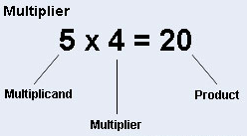
Round: You may need to round the answer up or down to complete the question

Problem 1a (teacher model)
Rachel and Ben are going on holiday. Ben has paid more for his luggage allowance and can take a bag which is 5 times heavier than Rachel. Rachels bag weighs 8g. How much do Rachel and Bens bags weigh altogether?
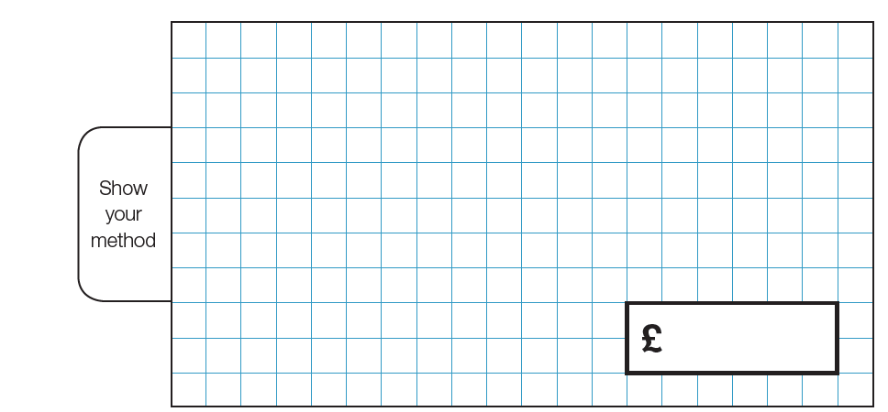

Problem 1b
Rachel and Ben are going on holiday. Ben has paid more for his luggage allowance and can take a bag which is 5 times heavier than Rachel. Rachels bag weighs 2,678g. How much do Rachel and Bens bags weigh altogether?

Problem 1c
Hermione is making a polygraph potion. The recipe asks her to put 6 times more beetle juice than bats blood. She needs to put in 2345ml of bats blood. What is the capacity of the beetle juice and the bats blood? Can you write your answer in litres?

Problem 2a (teacher model)
Joe wants to bake some bread. He needs 20 grams of flour to make 4 loaves. He has 5 packets of flour holding 3 grams each. How much more flour does he need to buy?

Problem 2b
Joe wants to bake some bread. He needs 4,789grams of flour to make 4 loaves. He has 5 packets of flour holding 750 grams each. How much more flour does he need to buy?

Problem 2c
Ned needs 7,035 litres of paint to spray the running track onto the school field. He has brought 9 tins of paint holding 645 ml each. How much more paint in millilitres does he need to buy? How many tins of paint would this be?

Problem 3a (teacher model)
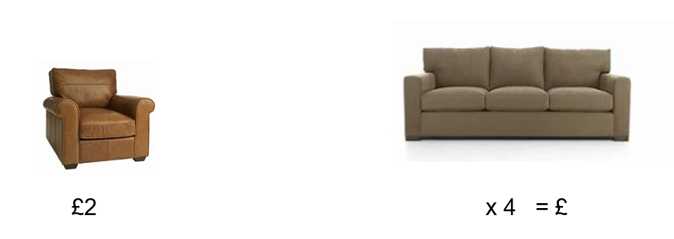
A single seat chair costs £2. A 3 - seater sofa costs 4 times this much. How much does the chair and the sofa cost?

Problem 3b
A single seat chair costs £2578. A 3 - seater sofa costs 4 times this much. How much does the chair and the sofa cost?

Problem 3c
There are 432 passengers booked to go on cruise holiday. There are also passengers booked to take a plane. There are 3 times as many passengers booked to take the plane that the cruise ship. How many passengers are booked to go on holiday in total?

