Summer is here!

Remote learning curriculum pack Lower Key Stage 2 (Years 3 and 4) Pack 11

HIAS REMOTE LEARNING CURRICULUM PACK

HIAS Teaching and Learning Team

Summer 2021

Final version

© Hampshire County Council
HIAS Remote Learning Curriculum Pack
Using the Remote Learning Materials
Dear Parents and carers,

Your school is sending you this pack of remote learning activities to help you to support your child at home. Your school may also have given you English and mathematics resources, and this pack of activities can supplement and work alongside these.
These activities are designed to help your child continue with learning across the wider curriculum, which is linked to the National Curriculum and will build on their existing skills, help them learn new ones, and allow for suitable independence.

How to use the pack and support your child:
- Learning at home is distinctive and different to school but try to establish a routine with your child. These activities are practical and creative and can be used to work alongside the other remote learning activities.
- Encourage your child to choose the activities that most interest them. Some will build on knowledge that they already have, and some will be newer learning; but all are designed to be practical and fun.
- Activities may need reading with your child and explaining, and you may need to help them find resources. All the activities can be adapted where needed to make them work for you.
- The activities have been designed to enable a good amount of independence. Let your child work at their own pace, encourage them and celebrate their achievements frequently.
- These activities could take approximately 2 to 3 hours to complete (approximately half a day) but can be spread across a few days if necessary. There is no time limit to the activities, they may take more or less than the suggested time.

Summer is here!

Key theme:

This theme is linked to all areas of the curriculum and is a chance to explore the theme of summer through many different subjects. Children will be able to create artwork, share their English and maths skills and explore their knowledge of geography, history and science in the following activities.

Lower Key Stage 2
The big idea

A Summer Work of Art

Key learning
Art:
Pupils should be taught:
- to create sketch books to record their observations and use them to review and revisit ideas.
- to improve their mastery of art and design techniques, including drawing, painting, and sculpture with a range of materials (for example, pencil, charcoal, paint, clay).
- about great artists, architects and designers in history.

How to do it
During the school year, there will have been many opportunities to learn new skills in art. This is the chance for you to choose your favourite art techniques to create a summer related work of art!

Think about:

- What style of art is your favourite? There is sketching, painting, 3D sculpture, textiles, collage and printing to name just a few. You will need to think about what materials you have available to use at home.
- What part of summer you are going to create. It could be:
- a landscape of a beautiful summer scene; like at the beach or a park
- a portrait of a person in summer clothes or doing a summer activity
- a still life of flowers or summer food
- a print or collage made up of summer images
- an abstract picture or model that reflects summer colours
- Are you going to use the style of an artist that you have studied at school? Here are a few artists that you might like to think about, but there are hundreds of others you might know:
- Vincent Van Gogh – sunflowers, the yellow house, wheat field with crows
- Georgia O’Keefe – red poppy, light iris, shells
- Yvonne Coomber – flower scenes
- Pierre-Auguste Renoir – people and scenes
- Claude Monet – flower gardens
- David Hockney – swimming pools
- What size will your artwork be? You will be limited by what you have available, but you could always tape some sheets of paper together to get a bigger size ‘canvas’.

Completing the activity:

- Collect all the materials that you will need for your work. If you are drawing/painting a still life then you will need to set up the items in an interesting position:
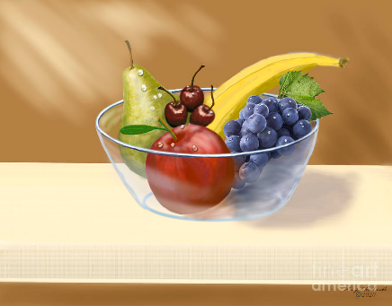

- Find somewhere you can work quietly.
- Enjoy!

Useful questions:
- Do you have all the resources you need for your artwork?
- Do you have a clear idea of the style?

Useful websites and resources:
https://www.yvonnecoomber.com/?UTM_source=GMB_listing&UTM_medium=organic
https://www.tate.org.uk/kids/make/paint-draw/create-art-van-gogh
https://www.tate.org.uk/kids/make
https://www.georgiaokeeffe.net/paintings.jsp
https://www.wikiart.org/en/pierre-auguste-renoir
https://blog.bridgemanimages.com/blog/here-comes-the-sun-famous-paintings-of-summer
https://www.tate.org.uk/art/artists/david-hockney-1293
Lower Key Stage 2
The big idea
A Summer of Sport

Key learning
Geography:
Pupils should extend their knowledge and understanding beyond the local area to include the United Kingdom and Europe, North and South America. This will include the location and characteristics of a range of the world’s most significant human and physical features. They should develop their use of geographical knowledge, understanding and skills to enhance their locational and place knowledge.
English:
Pupils should be able to write down their ideas with a reasonable degree of accuracy and with good sentence punctuation. In year 3 and 4, pupils should become more familiar with and confident in using language in a greater variety of situations, for a variety of audiences and purposes, including through formal presentations.

How to do it
The 2020 Summer Olympics were postponed until 2021 and will take place in Tokyo, Japan. They last for just over 2 weeks (23rd July to 8th August) and involve 339 events in 33 different sports. The Paralympic Games take place after – 24th August to 5th September; they are for athletes who have a disability. What is your favourite sport in the Olympic Games?

You are going to research a summer sport involved in the 2021 Olympic Games and/or Paralympic Games and present your findings in any way you choose.
Think about:

- Which 33 different sports are included in this summer’s games? There is a list here: https://www.olympic.org/all-information-about-the-olympic-games-tokyo-2020-and-covid-19 (click on the sports tab)
- There are 22 different sports included in the Paralympics. There is a list here: https://tokyo2020.org/en/paralympics/schedule/
- Do you already have a favourite one? If not, choose one that you find interesting. You could choose a sport you have never heard of so that you are extending your knowledge.
- What do you want to find out about that sport? Here are a few question ideas, but there are lots of others you could think of:
- When it was first introduced into the Olympics?
- Where in the world is it most common?
- What equipment is needed?
- Who holds the world records in this sport?
- Has someone from Great Britain ever won a medal?

Completing the activity:

- Choose the sport that you are going to find out about.
- Complete your research. Remember to write down your questions first and then record the answers as you go. You might find other interesting facts as you don your research, so remember to write them down as well.
- Decide how you will be presenting your findings. This could be a poster; a leaflet; a written report; a newspaper article, or you could use your computer or tablet to make a powerpoint or other digital presentation (imovie etc).
- Complete your work and share with your family or friends.

Useful questions
- Have you chosen a sport that is in the 2021 Tokyo games?
- Have you found out about how the sport is played and what is needed?
- Does your presentation look/sound interesting?

Useful websites and resources:
https://www.olympic.org/all-information-about-the-olympic-games-tokyo-2020-and-covid-19
https://tokyo2020.org/en/paralympics/schedule/

Lower Key Stage 2
The big idea
Ready, Set, Invent!

Key learning
Design and Technology:
Design
- use research and develop design criteria to inform the design of innovative, functional, appealing products that are fit for purpose, aimed at particular individuals or groups.
- generate, develop, model and communicate their ideas through discussion, annotated sketches, cross-sectional and exploded diagrams, prototypes, pattern pieces and computer-aided design.

How to do it
The summer is an amazing time to enjoy fun activities in the warm sunshine. However, there are often annoying little things that get in the way – like sand in your sandwiches or ice-cream dripping down your fingers. Wouldn’t it be great if someone invented something to help? Well now is your chance! Ready … Set … Invent!

Think about:

- What are some of the problems that annoy you or your family when you are enjoying your summer fun? Write these down as these will be part of the design process.
- Think about what the main issues are and what really needs to be solved.
- Don’t worry about how strange your idea seems – there really are crazy inventions out there:
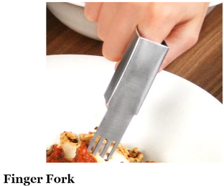
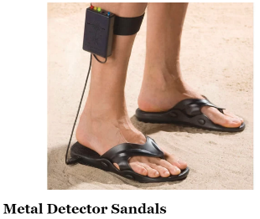

Completing the activity:

- Write down what the problem is that you are trying to solve – this is your design statement.
- Draw a series of clear diagrams of the ideas for your invention. Try to draw them from a range of different views:

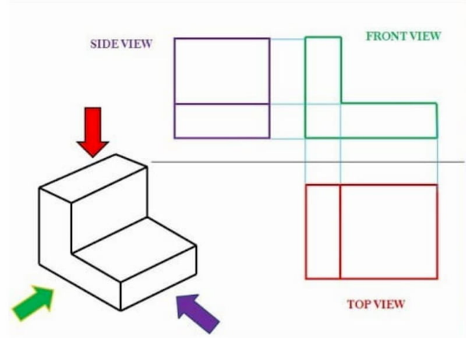
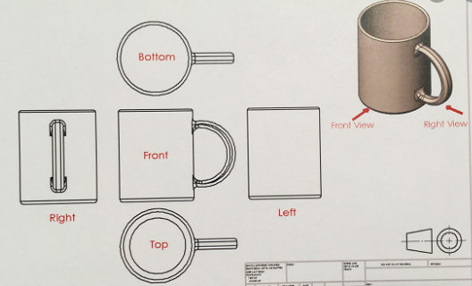

- Make sure you label the parts of your invention – what does each part do? You could try to include an exploded diagram:

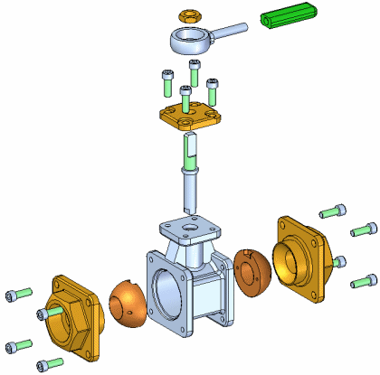

- Finally, write about how things will be better with your design! (Who knows – you might actually create your invention in the years to come).

Useful questions
- Is the problem something you really want to solve?
- Are the diagrams clear and labelled?
- Have you explained how things will be better when using your invention?
Useful websites and resources:
https://www.bbc.co.uk/bitesize/guides/zrx7xfr/revision/6
https://www.boredpanda.com/kids-inventions-turned-into-reality-inventors-project-dominic-wilcox/?utm_source=google&utm_medium=organic&utm_campaign=organic

Lower Key Stage 2
The big idea
Devise a general knowledge quiz about everything you have learnt about this year

Key learning
This activity can focus on any subjects or subjects that the child has enjoyed learning about this year. This could include maths, English, science, art, geography, or history.

How to do it
The starting point for this activity will be to discuss with the child what they have enjoyed about their learning this year. As the year has been a very different one for children this may be some work or project that they have undertaken at home or work that they have completed in their time in school.

Think about:

The subjects that could be covered are:
- Art
- Science
- Geography
- History
- Music
- English
- Maths

Completing the activity:
- Decide on the theme of the quiz and gather the information that you already know about the subject or subjects. There may need to be some time doing further research.
- Gather the materials needed to make the quiz. This could be in the form of white card or thin paper that can be cut into rectangles to make cards. If you have access to technology, then you could create a quiz on Kahoot (an adult would need to sign up for an account).
- Write a question on one side of the card and the answer on the back. This will really test the knowledge of all the family!
- Alternatively, the quiz could take the form of multiple-choice questions that could be written on one piece of paper.
- You can make the quiz more attractive by adding pictures to show the key learning in an attractive way.

Useful questions
- Will the quiz test one area or subject and why has this focus been chosen?
- How will the questions test your knowledge?
Useful websites and resources
https://kahoot.com/
https://www.quiz-maker.com/

HIAS Teaching and Learning Team

The HIAS Teaching and Learning Team give practical and supportive advice through coaching and mentoring teachers to improve outcomes for all pupils. They use a ‘plan, do, review’ approach to teaching and learning which broadly includes observation of teaching, personal target setting with areas given to improve, planning, demonstration of lessons and team teaching. The team focus their work on impact within the classroom.

They also work with Senior and Middle Leaders to develop the coaching model in their schools.

For further details referring to Primary Teaching and Learning support, please contact Sarah Sedgwick, Teaching and Learning Adviser: sarah.sedgwick@hants.gov.uk

For further details on the full range of services available please contact us using the following details:

Tel: 01962 874820 or email: hias.enquiries@hants.gov.uk.

