Year 3 GREEN
Please learn the following spellings.
You will be tested on them next Monday.
enough
rough
tough
cousin
trouble
strength
eight

This week, try this strategy:
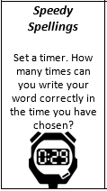

How many spellings can you fit into one sentence and still make sure that it makes sense?

Year 3 GREEN
Please learn the following spellings.
You will be tested on them next Monday.
enough
rough
tough
cousin
trouble
strength
eight

This week, try this strategy:

How many spellings can you fit into one sentence and still make sure that it makes sense?

