Monday 29th March – Year 4 Group 4
Please learn the following spellings.
You will be tested on them next Monday.
house
old
said
little
are
back
made
children

This week, try this strategy:
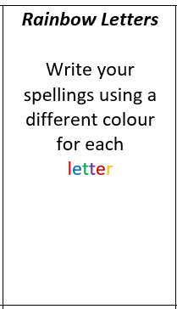

Monday 29th March – Year 4 Group 4
Please learn the following spellings.
You will be tested on them next Monday.
house
old
said
little
are
back
made
children

This week, try this strategy:

