Day 3 group 1 WALT: add and subtract mixed numbers and improper fractions |  | Teacher | Date:
 | I can consolidate adding and subtracting fractions with different denominators
 | I can add and subtract improper fractions
 | I can add and subtract mixed numbers
 | I can solve problems adding and subtracting mixed numbers and improper fractions

Green Step 1- consolidation
Add or subtract the following fractions. Remember to convert to the same denominator and then add/subtract the numerators. Give your answers as a mixed number.
Show workings in your book.

1) $\frac{3}{5}$ + $\frac{2}{10}$ = 2) $\frac{4}{5}$ + $\frac{2}{3}$ = 3) $\frac{6}{8}$ – $\frac{1}{3}$ = 4) $\frac{5}{6}$ – $\frac{1}{3}$ =

This square is divided into three parts.

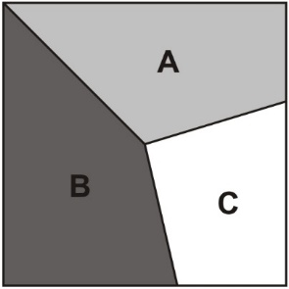
Part A is of the area of the square.
Part B is of the area of the square.
What fraction of the area of the square is part C?

2 marks

Green Group Step 2
Subtracting improper fractions

- $\frac{12}{5}$ – $\frac{6}{4}$ = 2) $\frac{23}{6}$ – $\frac{11}{3}$ = 3) $\frac{9}{2}$ – $\frac{12}{4}$ =

Green Group Step 3-
Give all answers as a mixed number

Green group Step 4
In this diagram, the number in each box is the sum of the two numbers below it.
Write the missing numbers.

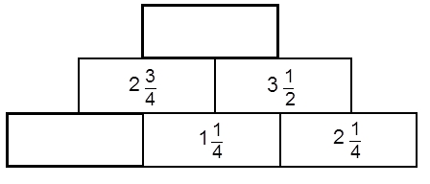
2 marks

The numbers in this sequence increase by the same amount each time.
Write the missing numbers.

The numbers in this sequence increase by the same amount each time.
Write the missing numbers.
$$1\frac{3}{5}$$
$$2\frac{2}{10}$$

