English day 3 WTS

Write what the characters could be saying in the speech bubbles. You will need to write this in your book and draw the bubble around what you have written.
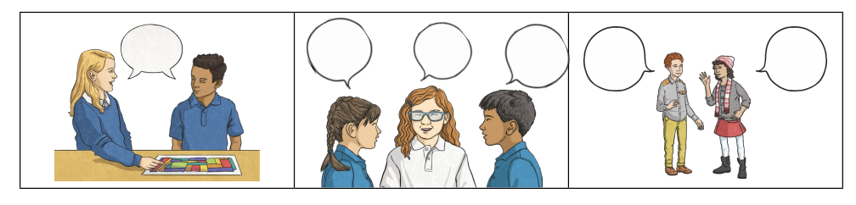
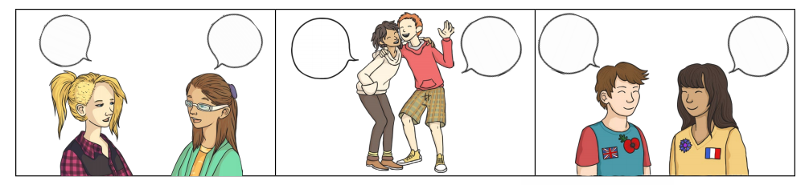

Now write down as many different words for ‘said’ that you can think of and make it into a colourful poster like this:
