English day 3 ARE
https://www.bbc.co.uk/bitesize/topics/zvwwxnb/articles/ztcp97h
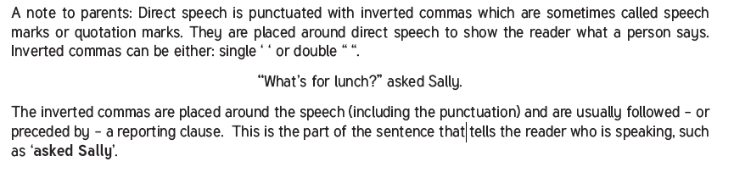
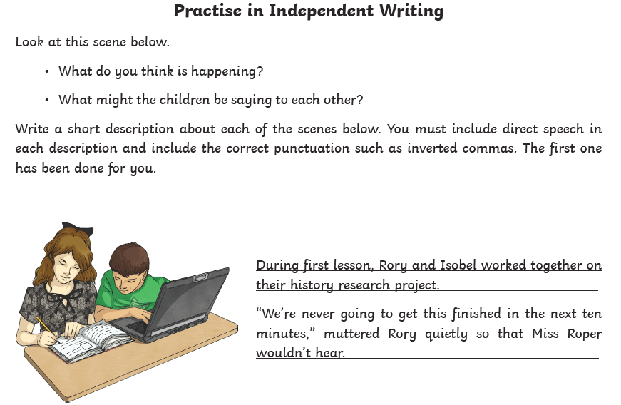
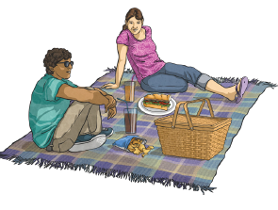

Now come up with some more of your own. Make sure you include information setting the scene- not just direct speech.

