English day 2 WTS

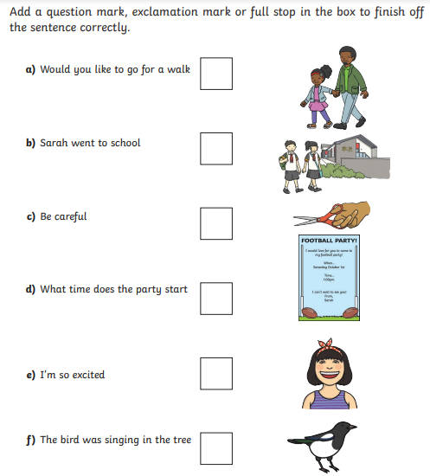

Now copy the sentences out in your best handwriting.
Can you write some of your own? Think carefully about spelling and use Fred Fingers to sound it out.

