English day 1 WTS

https://www.bbc.co.uk/bitesize/topics/zrqqtfr/articles/zy2r6yc

https://www.bbc.co.uk/bitesize/topics/zrqqtfr/articles/zpd8ng8

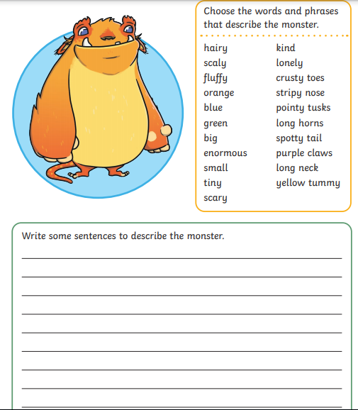

Now write some of your own descriptions about things around the house

