English day 1 ARE

https://www.bbc.co.uk/bitesize/articles/zhfgcqt

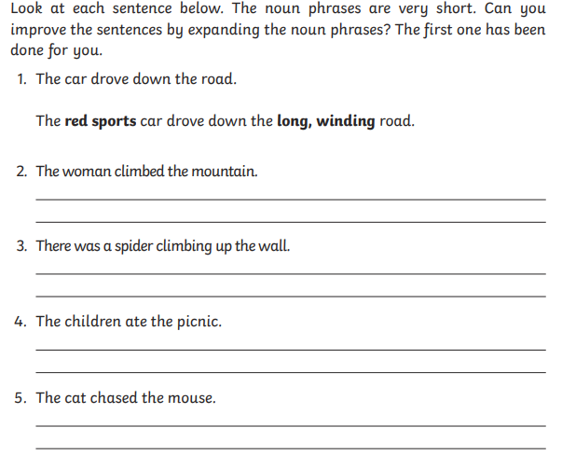

Now write some of your own about things around the house

