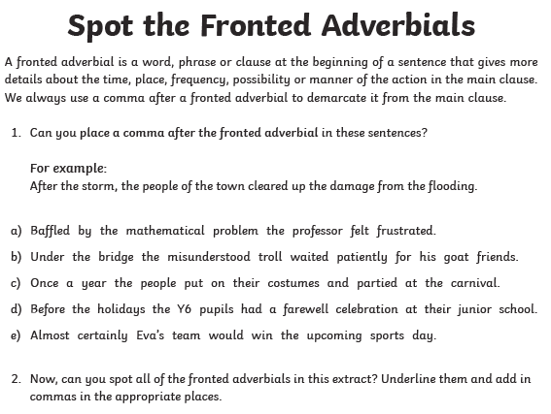
,
,
,
,
,
,
,
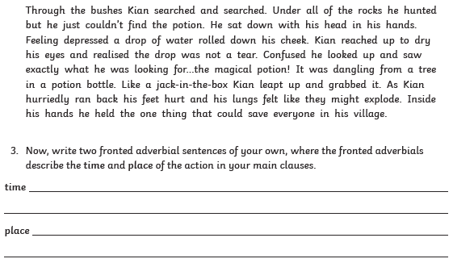
,
,
,
,
,

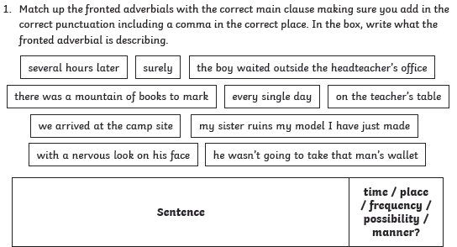
3.
Several hours later, we arrived at the campsite. | time
Surely, he wasn’t going to take that man’s wallet. | manner
Every single day, my sister ruins the model I have just made. | frequency
On the teacher’s table, there was a mountain of books to mark. | place
With a nervous look on his face, the boy waited outside the headteacher’s office. | manner

