WALT 2: Consolidate mental methods to add and subtract 3-digit numbers and 1’s, 10’s and 100’s. |  |  |  |  | Teacher | Jan 2021
1 | I can add and subtract 1’s crossing the tens boundary
2 | I can add and subtract 10’s crossing the hundreds boundary
3 | I can subtract 100’s crossing the thousands boundary
My effort today: |  | Needed to be better | Was good | Gave me a ‘Sense of Pride’
Vocabulary
Sum, Plus, Add, Addition: Combining two or more numbers to find the total.
Takeaway, Taking, Subtracting, Subtract, Minus: Taking away a smaller number from a larger number to find the total.
Step 1:
A) 135 + 6 B) 195 + 8 C) 785 + 7 D) 527 + 9 E) 236 + 7

F) 654 – 7 G) 671 – 5 H) 141 – 6 I) 202 – 4 J) 523 – 8

K) 123 + 9 L) 234 – 7 M) 378 + 6 N) 462 – 5 O) 356 + 8 P) 682 – 7

Step 2:
- 147 + 70 2) 195 + 30 3) 785 + 70 4) 526 + 90

- 231 + 80 6) 873 + 40 7) 578 + 30 8) 265 + 60

9) 654 – 70 10) 631 – 50 11) 141 – 60 12) 202 – 40

13) 523 – 60 14) 712 – 20 15) 230 – 40 16) 232 – 50

Step 3:
- 307 + 700 2) 995 + 300 3) 725 + 700 4) 519 + 900

5) 1200 – 30 6) 1150 – 200 7) 1400 – 600 8) 1568 – 700

Challenge
- Complete these bar models
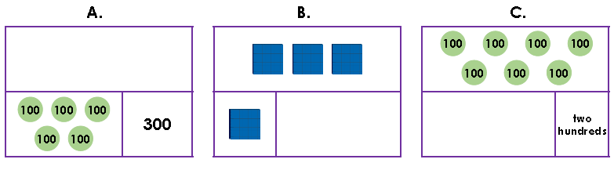

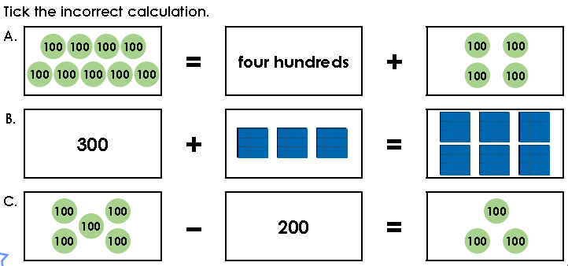

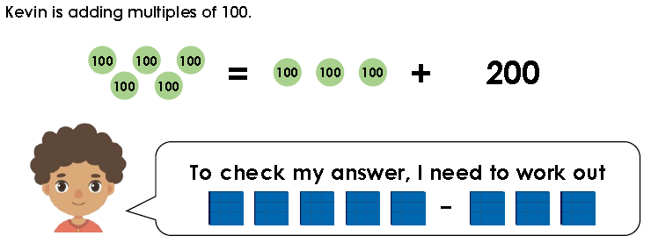
Is Kevin correct? Explain how you know.

