WALT 1: Consolidate our knowledge of place value. |  |  |  |  | Teacher | Jan 2021
1 | I can identify and partition numbers represented in different ways.
2 | I can identify different representations of 3 digit numbers.
3 | I can represent and partition different 3-digit numbers.
My effort today: |  | Needed to be better | Was good | Gave me a ‘Sense of Pride’
Vocabulary
Represent – to show, make or draw.
Place value – the value of the digit depending on its place in a number. E.g., in 315 the 1 is worth 10
Digit – symbol used to show a number. E.g., 8 is a one-digit number and 27 is a two-digit number.
Step 1 – Write the value of each representation in your books.
a)
2
3
b)
8
1

c)
7
0

d)
0
5
3
e)
2
Partition these number. For example, 67 = 60 + 7
f) 17 g) 23 h) 82 i) 34 j) 91 k) 56

Step 2
Match the picture with the value (make sure you USE A RULER )
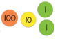 |  | - 142
 |  | - 242
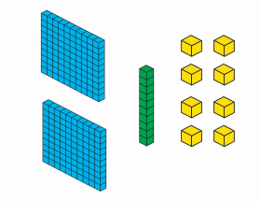 |  | - 112
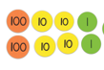 |  | - 218
 |  | - 620

Step 3
Draw and partition the following numbers in your books.
a) 230 b) 429 c) 549 d) 291 e) 387

