WALT 1: Consolidate our knowledge of place value. |  |  |  |  | Teacher | Jan 2021
1 | I can identify and partition numbers represented in different ways.
2 | I can identify different representations of 3 digit numbers.
3 | I can solve problems involving 3-digit numbers.
My effort today: |  | Needed to be better | Was good | Gave me a ‘Sense of Pride’
Vocabulary
Represent – to show, make or draw.
Place value – the value of the digit depending on its place in a number. E.g., in 315 the 1 is worth 10
Digit – symbol used to show a number. E.g., 8 is a one-digit number and 27 is a two-digit number.
Step 1 – Write the value of each representation in your books.
a)
2
3
5

b)
8
1
2

c)
7
9
0

d)
0
7
5

e)
3
8
2

Partition these number. For example, 267 = 200 + 60 + 7
f) 283 g) 723 h) 812 i) 304 j) 291 k) 956

Step 2
A | B | C
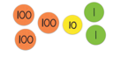 | 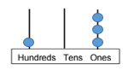 | 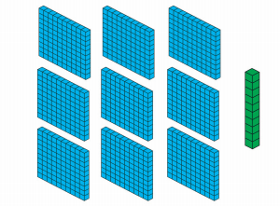
D | E | F
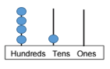 | 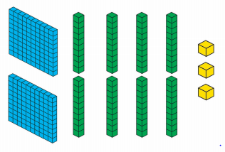 | 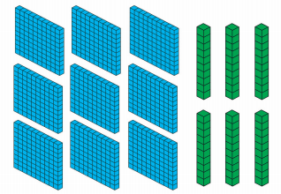
G | H | I
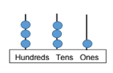 | 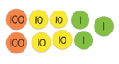 | 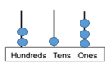
J | K
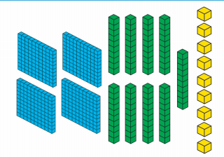 | 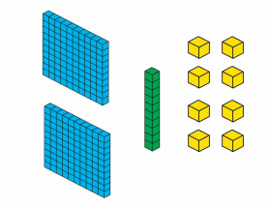
Write the value of each representation in your books.

Step 3
Question 1

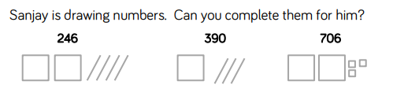

Question 2

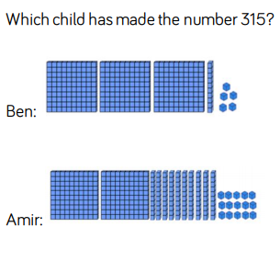

Question 3

