Compare rainforest animals to animals from the UK.
Rainforest –
Common Chimpanzee
https://wwf.panda.org/discover/knowledge_hub/endangered_species/great_apes/chimpanzees/?
Breeding occurs throughout the year. Following a gestation period ranging from 202 and 261 days, females give birth to a single young, and occasionally twins, every 5-6 years. Of these offspring, about three will survive.
For the first 6 months, the young is carried around clinging to its mother's underbelly, and after that it rides on its mother's back. It weans at 3.5-4.5 years, while still remaining reliant on its mother for a longer period, sometimes up to 10 years. Although chimpanzees reach adulthood at about 7 years, females do not produce offspring until they reach 13-14 years of age. Chimpanzees may live until they are over 60.
Leopard –
Life Cycle: When a leopard cat gives birth, she has 1-4 cubs (usually 2-3), which are born with their eyes closed. They open their eyes at 10 years old, an become independent by the age of eighteen months. Sometimes, males rear their young. Cubs then reach adulthood at the age of 8-10 months, and may normally live up to 15 years of age.
- They may also begin to change colour over their life cycle.
- They have a short life span.
- The average leopard cat passes away at 10-13 years old.
Crowned lemur
https://www.marwell.org.uk/zoo/explore/animals/86/crowned-lemur
Crowned lemurs breed between late May and early June. Young are born from mid-September to the end of October. When infants are born they weigh about 60 grams. They are weaned at 6 to 7 months old. Males and females are able to breed from about 20 months of age. They can live for 15-20 years.

UK – Mammals
Fox – https://www.woodlandtrust.org.uk/trees-woods-and-wildlife/animals/mammals/fox/
Foxes are social animals and live in loose family groups. These are normally made up of a breeding male, female and their young. In spring, the female will give birth to a litter of cubs in an underground den. Normally, four or five cubs will be born and they will be cared for by both the male and female. By autumn, the cubs are fully self-sufficient. Some will leave to establish their own territories, while others may remain with the family group. Those that stay sometimes help their parents to raise the following year’s young.
Badger - Litters of 2-3 cubs are born around February blind and hairless in the safety of the nest. They usually appear above ground at about 8 weeks, and weaning usually takes about 12 weeks. By late summer they are usually feeding independently but can be adversely affected by drought at this time, causing starvation. Badgers can live in social groups of two to 23 adults, but usually around six. They can live for up to 14 years.
European rabbits –
Their population increases very fast. The breeding period starts in autumn and continues till summer. They become can have young starting at the age of three to four years. They give birth to four-six kittens, born blind, deaf and without fur. Babies are kept in nesting burrows till the period they start walking. They can

Rainforest animals –

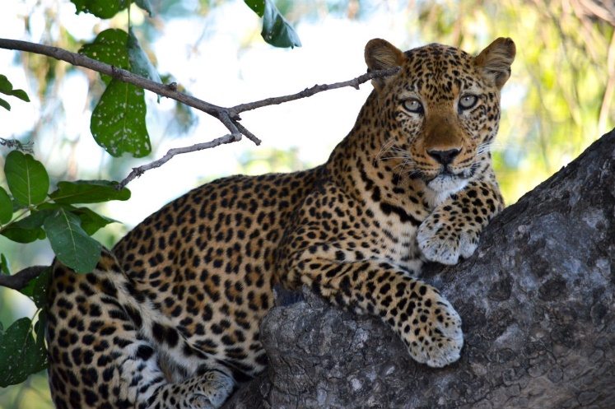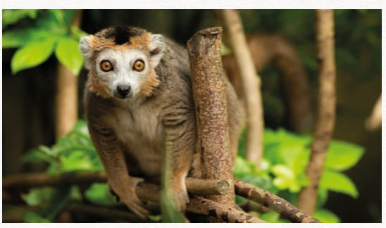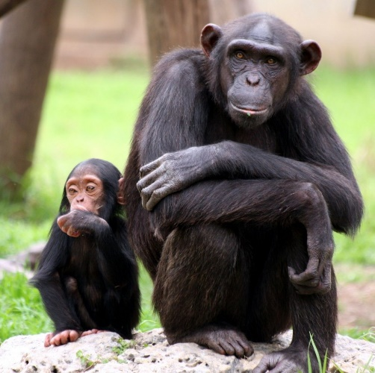
UK animals
