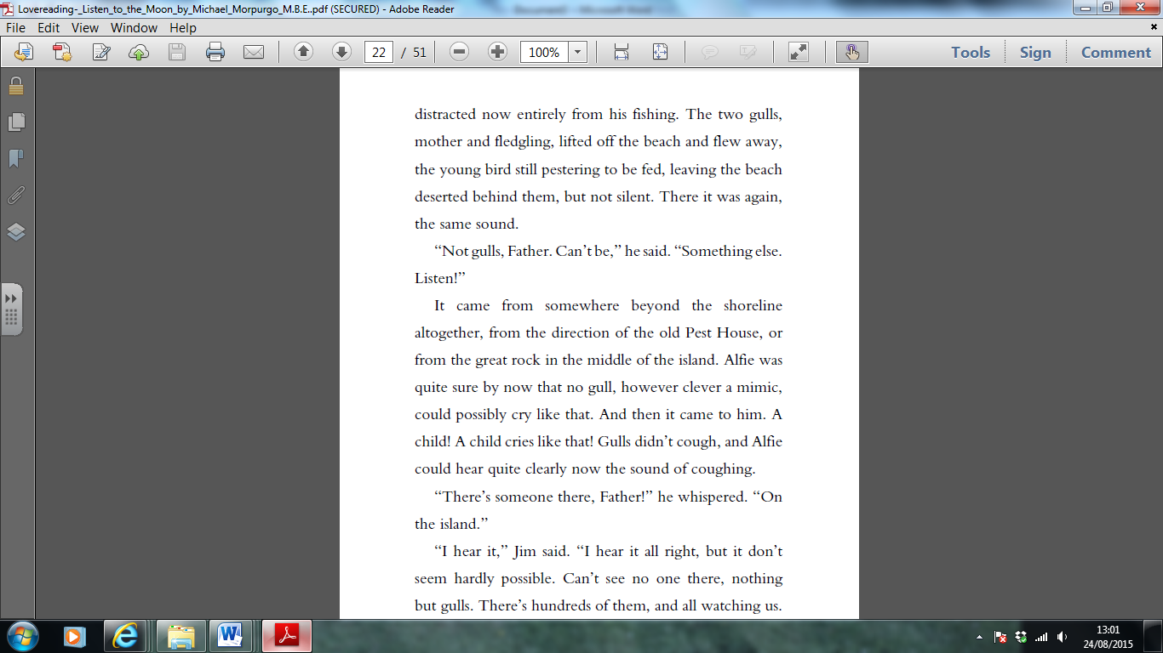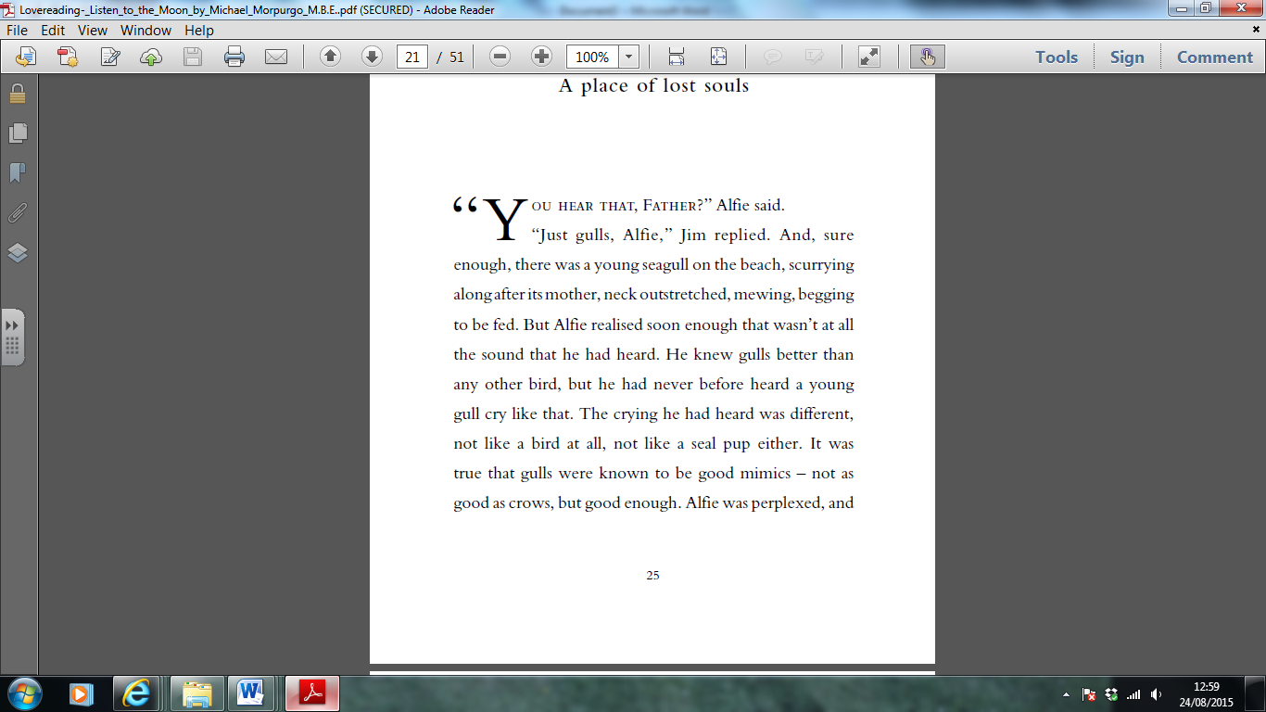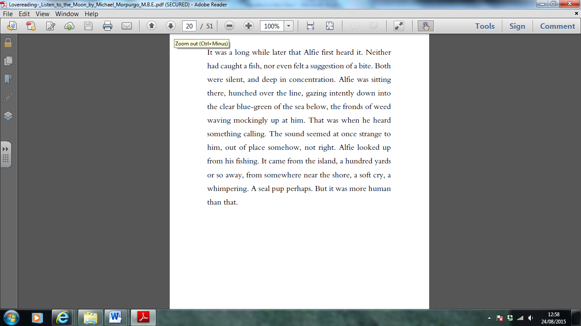From ‘Listen to the Moon’ by Michael Morpurgo

Retrieving Information

1. Use a dictionary to find the definition of:
2. fronds
3. intently
4. perplexed
5. Find and copy a word that shows the noise that Alfie hears is a sad one.
6. What is the relationship between Jim and Alfie?

Making Inferences

1. How do you know that Alfie spends a lot a time out on the coast?
2. Have Alfie and Jim just arrived or have they been out for a while? How do you know?
3. Why do you think that Alfie whispers to his father at the end of the extract?

Writer’s choices

1. Why do you think the writer has started with the line, “It was a long while later that Alfie first heard it.”? What mood does this create?
2. Why do you think the author describes the weed as “waving mockingly”?

Challenge question

1. Why might Jim think that is not possible for a child to be on the island?