L1 - Write the diary of a plant

Research how plants live and grow, including what the different parts of a plant does before you write your diary entry:

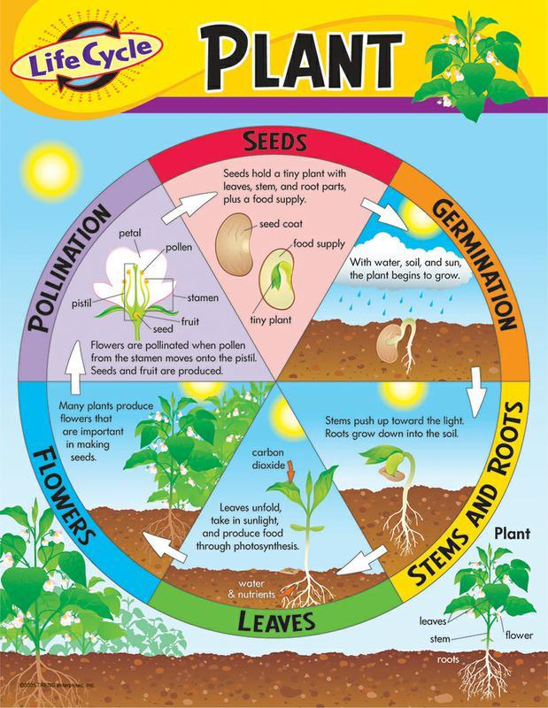

[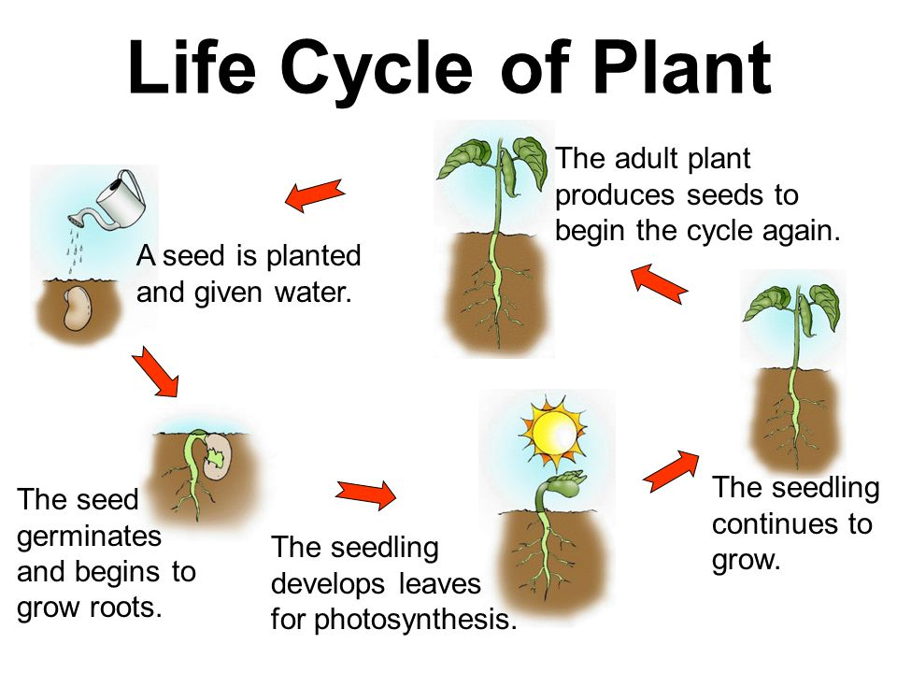](https://www.google.com/url?sa=i&url=https%3A%2F%2Fslideplayer.com%2Fslide%2F8515694%2F&psig=AOvVaw1OcVMU4ety9Y6sdU-ax-KO&ust=1609938803466000&source=images&cd=vfe&ved=0CAIQjRxqFwoTCIDah8bvhO4CFQAAAAAdAAAAABAE)

[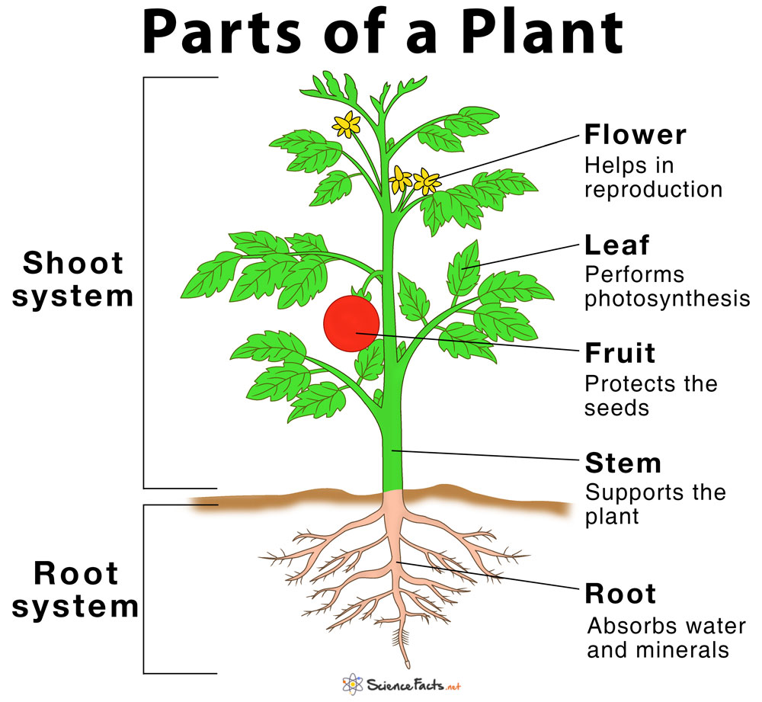](https://www.google.com/url?sa=i&url=https%3A%2F%2Fwww.pinterest.com%2Fpin%2F742108844837155767%2F&psig=AOvVaw3sSj8U3ABFZ2jhMh4mS2Id&ust=1609935896260000&source=images&cd=vfe&ved=0CAIQjRxqFwoTCNC75NvkhO4CFQAAAAAdAAAAABAE)

Photosynthesis:

[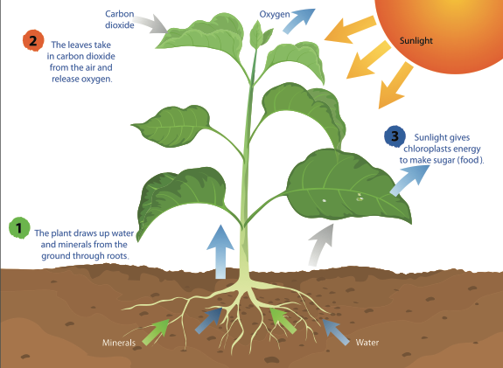](https://www.google.com/url?sa=i&url=https%3A%2F%2Fssec.si.edu%2Fstemvisions-blog%2Fwhat-photosynthesis&psig=AOvVaw2SxSIo5lCwfJc1w-jz1wEs&ust=1609936382826000&source=images&cd=vfe&ved=0CAIQjRxqFwoTCPDt6sPmhO4CFQAAAAAdAAAAABAU)