[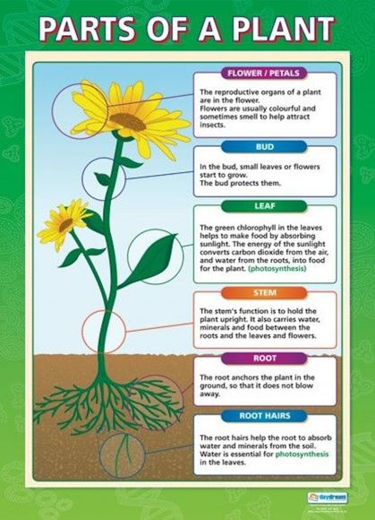](https://www.google.com/url?sa=i&url=https%3A%2F%2Fwww.hillmead.org%2F616%2Fblog%2Fpost%2F163%2Fdissecting-plants-year-3&psig=AOvVaw0tbzmO4Er_RQfl2Bdba0zT&ust=1609939356185000&source=images&cd=vfe&ved=0CAIQjRxqFwoTCLDE383xhO4CFQAAAAAdAAAAABAE)

[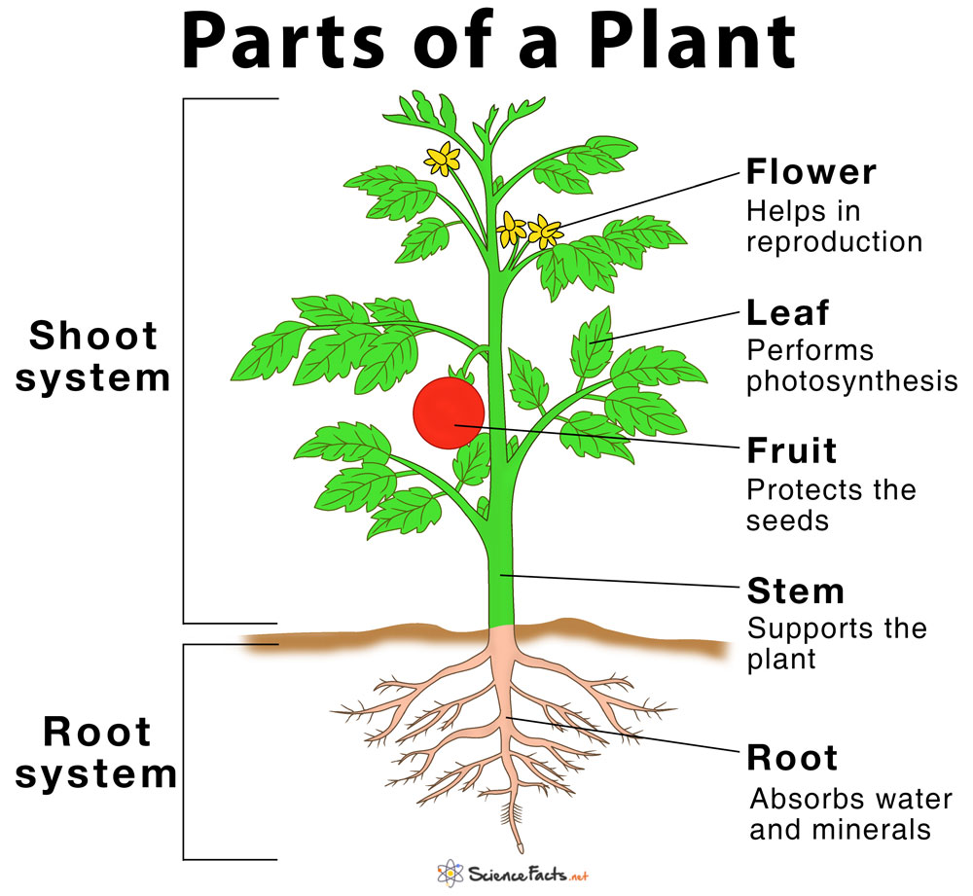](https://www.google.com/url?sa=i&url=https%3A%2F%2Fwww.pinterest.com%2Fpin%2F742108844837155767%2F&psig=AOvVaw3sSj8U3ABFZ2jhMh4mS2Id&ust=1609935896260000&source=images&cd=vfe&ved=0CAIQjRxqFwoTCNC75NvkhO4CFQAAAAAdAAAAABAE)