WALT 3: Use expanded multiplication to multiply 2 - digit numbers by 1 digit |  |  |  |  | HONESTY
1 | I can use my known facts to calculate related multiplication number sentences
2 | I can multiply 2- digit numbers by a single digit when calculations are set out for me.
3 | I can set out my own calculations to multiply 2 - digit numbers by a single digit.
My effort today: |  | Needed to be better | Was good | Gave me a ‘Sense of Pride’
Vocabulary
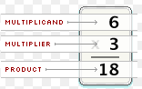
Multiple = a number that may be divided by another a certain number of times without a remainder
Multiplicand: First number in a multiplication sentence e.g. 5 x 4 = 20
Multiplier: Second number in a multiplication sentence e.g. 5 x 4 = 20
Product: The answer from multiplying two numbers (the multiplicand and the multiplier together.

Consolidation 1:
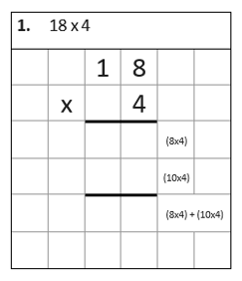
This is an example of expanded multiplication. Lay your questions out using the squares in your book and your ruler. Remember to put the number sentences in brackets.
7 2
4 0
3 2
- 19 x 5 = 95 2) 17 x 4 = 68 3) 16 x 3 = 48
Consolidation 2:

1) 3 x 3 = 9 2) 3 x 5 = 15 3) 2 x 3 = 6 4) 6 x 2 = 12
30 x 3 = 90 30 x 5 = 150 20 x 3 = 60 60 x 2 = 120

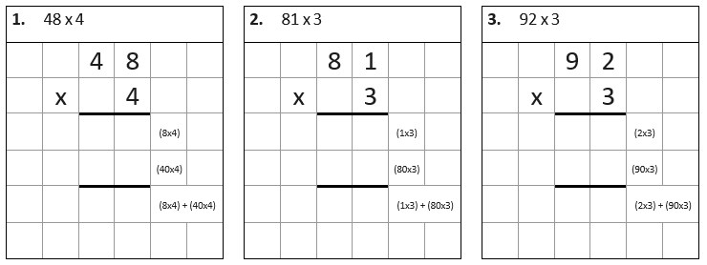
Step 1

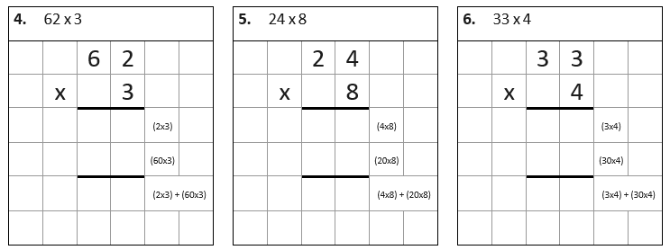

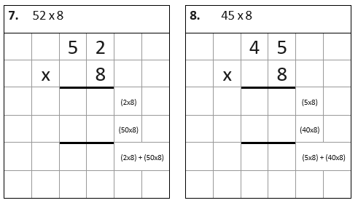
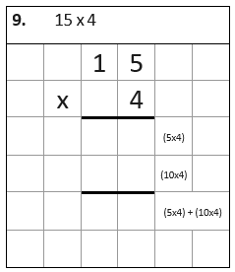

Step 3
Use expanded multiplication to solve these questions. Set the calculations out in your book. Remember to show you calculations.

- 36 x 4 = 144 2) 29 x 3 = 87 3) 42 x 6 = 252

4) 37 x 5 = 185 5) 34 x 7 = 238 6) 27 x 5 = 135

7) 32 x 3 = 96 8) 45 x 3 = 135 9) 78 x 2 = 156

Step 4 – fluency

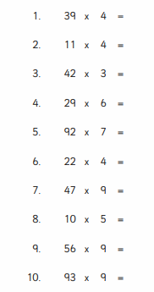
Set these calculations out in your book. Solve them using the expanded method.

126

