WALT 1: Use short division without regrouping |  | Teacher
1 | I can use short division to divide a 3 - digit number. (Step 2)
2 | I can develop my fluency using short division for larger numbers (Step 3)
Vocabulary
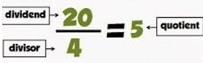
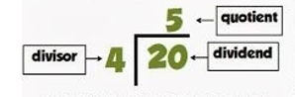
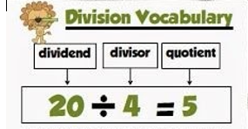

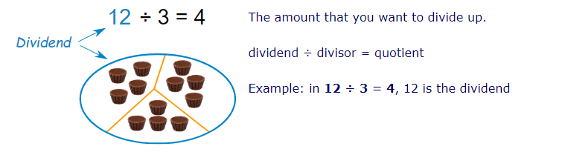

For a reminder of how to do short division, watch the video but stop at 1 min 10 seconds.
https://www.youtube.com/watch?v=DVO_SyPYvEs

Step 1
Use short division to solve these calculations.

1) 390 ÷ 3 = 2) 484 ÷ 4 = 3) 880 ÷ 4 =
4) 396 ÷ 3 = 5) 246 ÷ 2 = 6) 639 ÷ 3 =
7) 804 ÷ 4 =

Step 2
1) 8862 ÷ 2 = 2) 9330 ÷ 3 = 3) 4844 ÷ 4 =
4) 6428 ÷ 2 = 5) 3639 ÷ 3 = 6) 4804 ÷ 4 =

