WALT: Use short division with regrouping |  | Teacher
1 | I can use short division to divide a 3- and 4-digit number with re-grouping. (Step 1)
2 | I can use short division to divide a 3-digit number with re-grouping and remainders. (Step 2)
3 | I can use short division to divide 4-digit numbers which may need regrouping more than once. (Step 3)
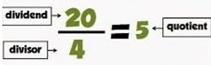
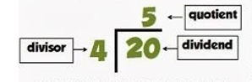
Vocabulary
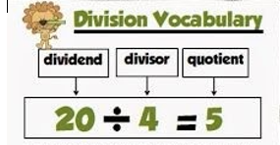

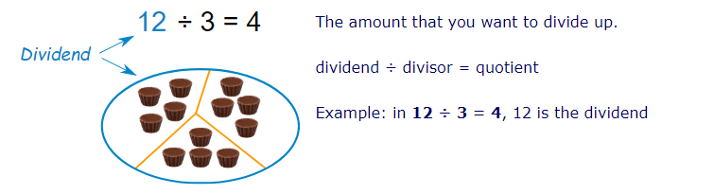

For a reminder on how to do short division, watch the video: https://www.youtube.com/watch?v=DVO_SyPYvEs

Step 1
Use short division to solve these number sentences.

1) 846 ÷ 6 = 2) 528 ÷ 4 = 3) 477 ÷ 3 =
4) 945 ÷ 7 = 5) 8255 ÷ 5 = 6) 9486 ÷ 3 =

Step 2
1) 7538 ÷ 3 = 2) 6876 ÷ 4 = 3) 8425 ÷ 6 =
4) 6527 ÷ 5 =

Step 3

- 29 people are going on a journey. Each car holds 6 people. How many cars would be needed?

2) A ride at Thorpe park can hold up to 4 people per carriage. There are 33 people in the queue. How many carriages will they need?

3) A school is taking their pupils on a river trip. Each canoe can hold up to 3 people. There are 29 pupils on the trip. How many canoes will they need?
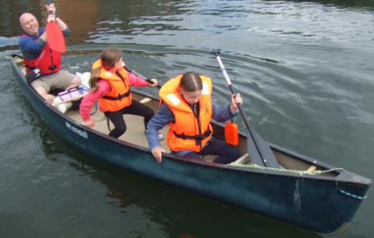

4) 76 children in Year 5 are going on a school trip. Each minibus holds 10 people. How many minibuses would be needed?

Step 4
1) Joe has 29 tokens for the Juke Box. He can play 1 track for every 6 tokens. How many tracks can he play?

2) Chocolate biscuits are £3 each. James has £20. How many chocolate biscuits can he buy?

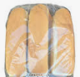
3) Simon needs 5 cherries to complete each Bakewell tart. He was 43 cherries. How many Bakewell tarts can he complete?

4) Rachel works in a supermarket and she needs to put 3 bread rolls into every pack. She has 26 bread rolls. How many complete packs can she make?

