Day 2 – Group 2: Recognise and show simple equivalent fractions with small denominators.
1 | I can use concrete resources to find fractions equivalent to ½
2 | I can write equivalent fractions to ½
3 | Shade the bar models in to find the equivalent fractions
Warm up

Step 1
Investigate which fractions are equivalent to a half using the practical resources. Explain what you have found out about the numerator and the denominator.
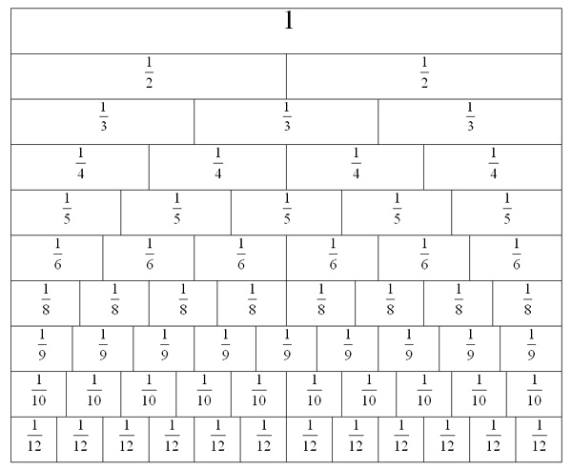
Shade in the fractions below that are equivalent to a half.

Step 2
Shade the bar models in to find the equivalent fractions
