Day 1 – Group 1: Solve problems involving the relative size of two quantities
Solve simple problems involving the relative sizes of two quantises (input)
Solve problems scaling recipes
Solve problems in a variety of contexts

1) Four cookies cost £3.20. How much would you pay for:
a) 8 cookies b) 20 cookies c) 10 cookies d) 15 cookies

2) 3 pens cost £1.20. How much would you pay for:
a) 6 pens b) 9 pens c) 1 pen d) 15 pens

3) To make soup for 4 people, you need 800g of tomatoes and 600g of cream. Tom only has 400g of tomatoes. How much cream should he use?

Q1.
Here are the ingredients for fish pie for two people.

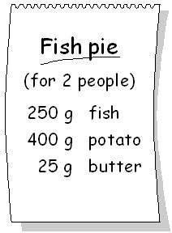
Omar makes fish pie for 3 people.
How many grams of fish should he use?

2 marks

Q2.
Here is a recipe for pasta sauce.
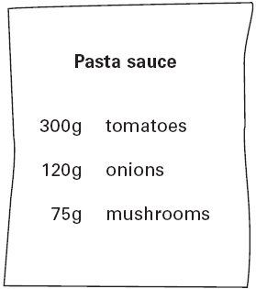
Josh makes the pasta sauce using 900 g of tomatoes.
What weight of onions should he use?

1 mark

Q5.
Here is a recipe for fruit smoothies.

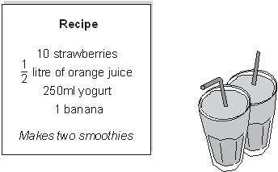
Stefan uses the recipe to make smoothies.
He uses 1 litre of orange juice.
How many strawberries does he use?
1 mark

Q6.
Chen is cooking some pasta.  The recipe says he needs 350 grams of pasta for 4 people. | 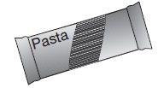
How many kilograms of pasta does he need for 8 people?

2 marks

Q1.
A stack of 10 identical boxes is 140 cm tall.
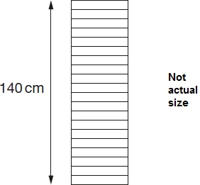
Stefan takes three boxes off the top.
How tall is the stack now?
Q2.
A stack of 20 identical boxes is 140 cm tall.
300cm tall.
300cm
Stefan takes two boxes off the top.
How tall is the stack now?

Q3.
A stack of 10 identical boxes is 140 cm tall.
1200cm tall.
1200cm
Stefan takes four boxes off the top.
How tall is the stack now?

Q3.
A stack of 10 identical boxes is 140 cm tall.
1080cm tall.
1080cm
Stefan takes three boxes off the top.
How tall is the stack now?

Q4.

Peanuts cost 60p for 100 grams.
What is the cost of 350 grams of peanuts?

2 mark
Raisins cost 80p for 100 grams.
Jack pays £2 for a bag of raisins.
How many grams of raisins does he get?

2 mark

Q5.

Cheddar cheese costs £7.50 for 1 kg.
Marie buys 200 grams of cheddar cheese.
How much does she pay?
1 mark
Cream cheese costs £3.60 for 1 kg.
Robbie buys a pot of cream cheese for 90p.

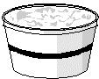
How many grams of cream cheese does he buy?

2 marks

Q9.
These are the prices of cheese in a shop.
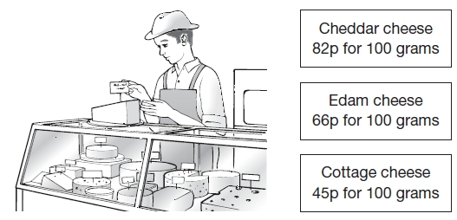
Mina buys 200 g of Cheddar cheese and 150 g of Edam cheese.
How much does she pay altogether?

2 marks
Seb buys some cottage cheese for £1.35.
How many grams of cottage cheese does he get?
1 mark

