Day 1 – Group 2: Compare and order unit fractions and fractions with the same denominator.
1 | I can colour in unit fractions.
2 | I can order units fractions according to their size.
3 | I can explain why I would rather have one fraction than another.
Vocabulary:
Fraction – Any equal part of a group, number or whole.
Numerator – The top number. It is the number of parts we have.
Denominator – The bottom number. It is the total number of equal parts that we have divided the whole into.
half/third/quarter/fifth/sixth/seventh/eighth/ninth/tenth etc – The names given to fractions e.g. half is divided into two equal parts, fifths are divided into 5 equal parts etc.
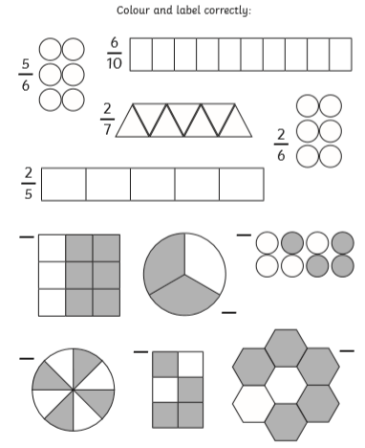
Colour and label the images correctly.

Step 1
Colour in 1 section from each fraction circle. Write the fraction coloured next to or under the circle.
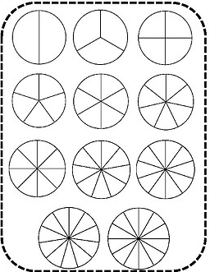

Step 2
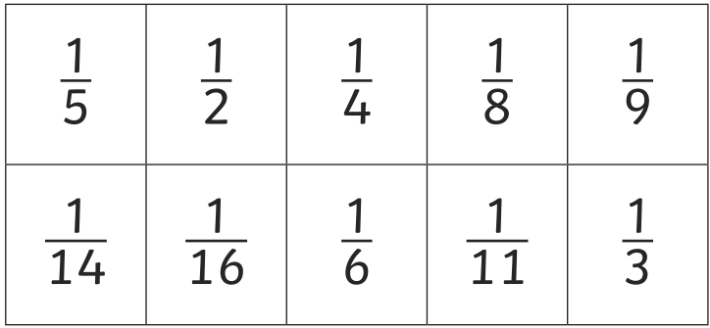
Using the fraction wheels you coloured in for Step 1 to help, cut out the fraction cards now and arrange them in order of size starting with the smallest.

Step 3

What would you rather have?
- Would you rather have 1 sixth of a cake or 1 third of a cake? Explain why.
- Would you rather have 1 half of a pizza or 1 eighth of a pizza? Explain why.
- Would you rather have 1 fifth of a bar of chocolate or 1 sixth of the bar? Explain why.

