Day 1 Group 1: Convert between mixed numbers and improper fractions and write number >1 as a mixed number.
1 | I can consolidate writing improper fractions and mixed numbers
2 | I can convert improper fractions to mixed numbers

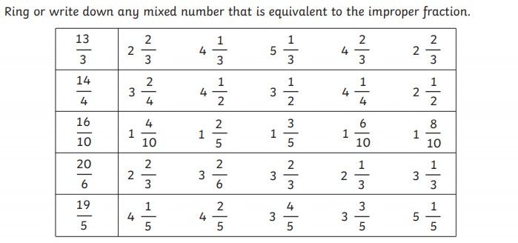

Convert the following improper fractions to mixed numbers:

Convert the following mixed numbers to improper fractions:

