Day 1- fractions of amounts
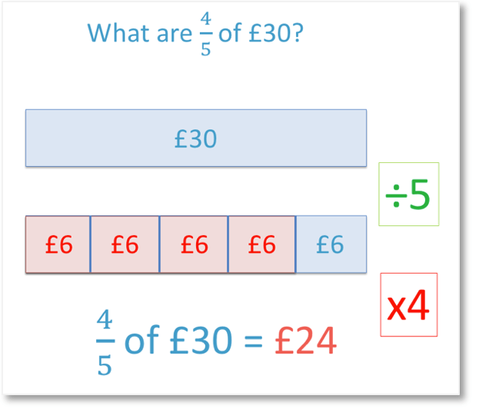
Step 1: Draw a bar model to represent the following fractions of amounts:
Step 2: Calculate the following fractions of amounts by dividing the number by the denominator and then multiplying the answer by the numerator:
Step 3: Complete the following, showing your method..

Step 4: Complete the following using a bar model to support you. The first one has been done for you.

1)
56 ÷ 7

8 | 8 | 8 | 8 | 8 | 8 | 8 | 8 | 8 | 8 | 8

8 x 12 = 96 tulips

