12th October 2020
Dear Parents and Carers,
I had hoped that we would be able to hold parents evening in school this half term enabling you to see your children’s classrooms and to meet their teachers face to face (albeit from a distance). Having taken some time to reflect upon this plan and the increasing number of positive cases within Hampshire, I am afraid that this is not going to be possible.
Parents evening will now take place via a phone call to each family on the same dates we shared at the start of the year. These are shown below:
19th October Parents Evening 4-7pm 3AT, 4IC, 5SG, 5SH, 6SB and 6GR
20th October Parents evening 4-6pm 3AT, 4IC, 5SG, 5SH, 6SB and 6GR
21st October Parents evening 4-7pm 3MD, 4JS, 5JH, 5MC and 6AF
22nd October Parents evening 4-6pm 3MD, 4JS, 5JH, 5MC and 6AF
Mrs Williamson will be releasing booking information this week. If you have changed your mobile or home telephone numbers and have not updated school, please do so – this is essential information for us to have so that we can both safeguard your children and maintain good communication with you at all times. For children whose parents do not live together, two appointments can be booked.
Our teachers have got to know your children really well in the first five weeks of this term and are excited to talk to you about their achievements. I’m afraid conversations are going to have to end after 9 minutes to enable teachers to keep to their schedule. If, having spoken to your child’s class teacher, you would like the opportunity to discuss anything in more detail, please contact the school office so that they can arrange for teachers to give you a call.
I am really sorry that we have had to change our plans but hope that you can understand the reasons for this.
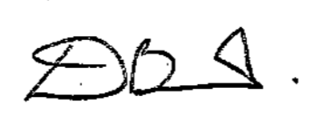

David Bessant
Headteacher
Mill Rythe Junior School

