WALT: Know what makes a healthy diet and explore what influences our food choices  A healthy diet is one that is balanced. We need to eat the correct amount from each food group: Fruit and vegetable, Carbohydrates, Protein, Dairy and Fats.  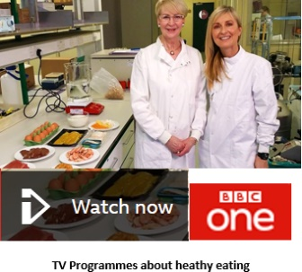  What we eat every day is decided by the people who look after us. But who influences their decisions?  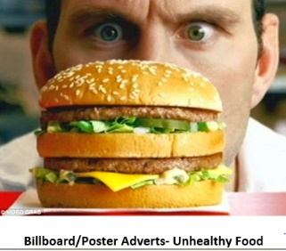  What we watch on TV, see on posters, view on social media, deals in the supermarket and what we hear on the radio could be influencing what we eat. | WALT: I know the characteristics of an active lifestyle.  Mental – affecting your mind and thoughts  Physical – affecting your body  Being active makes us happier, we spend more time outside and with others, we sleep better and it helps us maintain our weight. It also makes us better learners as we can concentrate more and we find it easier to remember what we’ve learned. Being part of a team or joining you community is a good way to stat active. | WALT: Know the importance of daily and weekly exercise  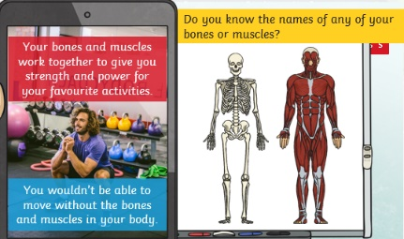  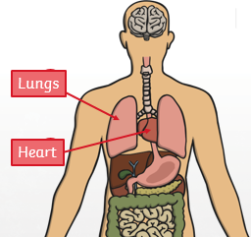  Exercising has many benefits, but it is especially good for maintaining a healthy heart, lungs and brain.  It is recommended that you should exercise for 60 minutes a day. This doesn’t have to be all in one go. Keeping an exercise diary will help you see how much exercise you do and highlights times when you could do more.
WALT: Explore the risks of an inactive lifestyle  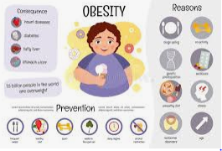  Risk - a dangerous situation  Lifestyle – a way in which a person lives  Obesity – being very over weight  Being inactive has a negative effect on our physical and mental wellbeing. More and more we use cars and play games indoors. This makes us more prone to illness, we have less energy than usual and we are more likely to feel unhappy. The effect on our body can last a life time | WALT: Know about safe and unsafe exposure to the sun  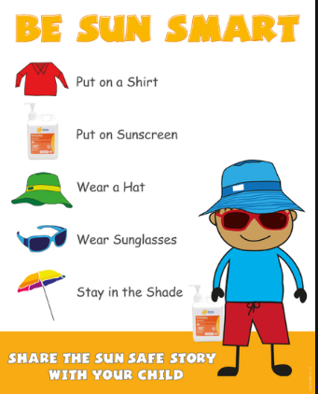  The sun radiates light to earth, and part of that lights consists of UV rays. When these rays reach the skin, they cause tanning, burning and other skin damage. Melanin is a chemical found in the skin and it is the body’s first line of defence. Melanin absorbs dangerous UV rays before they cause skin damage. Sun burn develops when the amount of UV exposure is greater than what can be protected against by the skin’s own melanin. There are many ways in which you can help your body stay safe too.

Tier Three Vocabulary

balanced lifestyles | health | mental | emotional | physical | influence | inactive
positive | neutral | negative | consequence | active | melanin | ultraviolet
Vegetarian | fibre | protein | carbohydrate | fat | vegetables | fruit

