WALT 1: Understand the effects different drugs-legal and illegal can have on the body  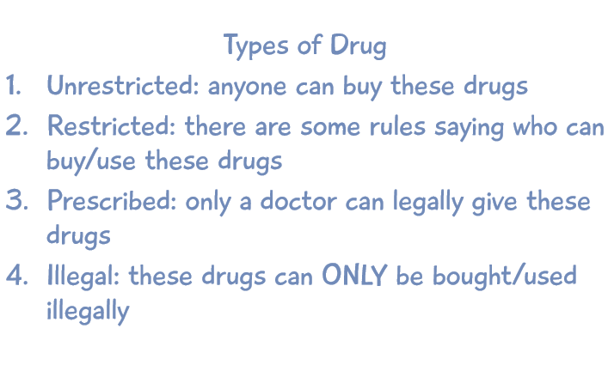  Do you know the effects of drinking too much alcohol on your major organs? It effects your brain, heart and liver | WALT 2: I know that there are laws surrounding the  use of legal drugs  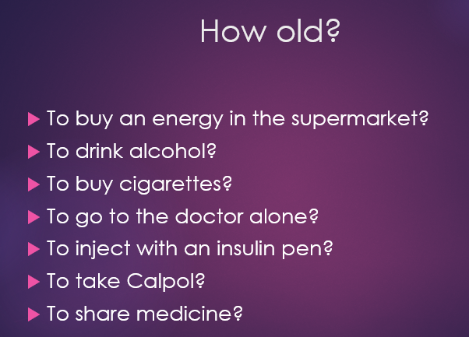  Why do you think there are age restrictions on certain drugs?
WALT 3: know strategies for recognising and managing peer influence and a desire for peer approval in friendships  Who are my peers? Your peers are people who are of a similar age and background to you. They can be your classmates, teammates, neighbours of a similar age or family members that are close in age to you  Peer pressure: When a person or a group of people try to convince you to behave or act in a certain way. | 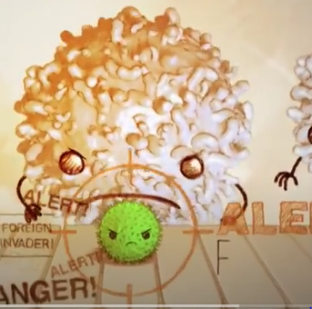  WALT 4: I know what allergies, immunisation and vaccinations are  White blood cells protect us again germs, viruses and bacteria by attacking them. Not only do they attack them, but they remember what they look like the next time we come across them. Second time round, we might not even know we even caught the virus. Out bodies are pretty awesome! Vaccination allow our white blood cells to build an army to protect us against a disease before we even catch it. This was discovered by Edward Jenner in 1796.

Tier Three Vocabulary
disease | antibodies, | curiosity | criticise | virus | immunity | peer
unrestricted | identity | individual | persuade | stomach | illegal | legal
prescription | benefits | temperature | lifestyle | pressure | allergies | vaccinations

