Lesson 1 – The 5 Kingdoms  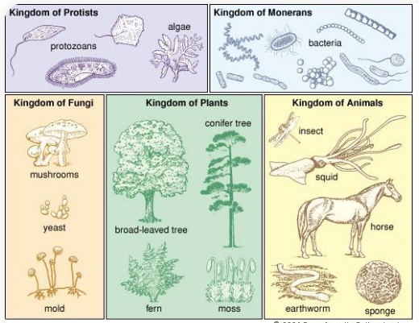 | Lesson 2 – Plants  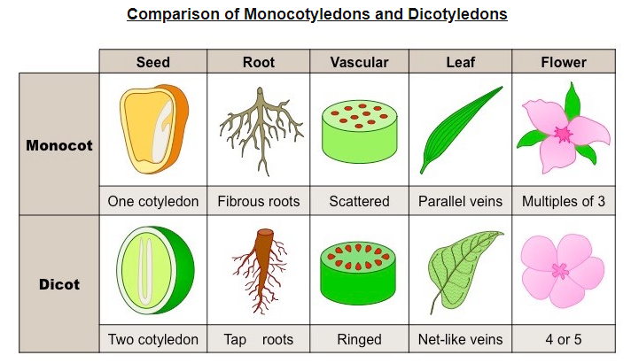
Lesson 3 – Microorganisms  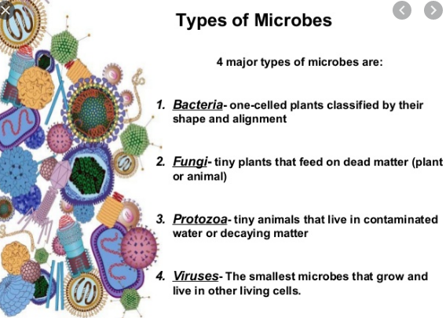 | Lesson 4 & 5 – Vertebrates and invertebrates  