Long Term Overview: The Writing & Reading Journey for Year 6 Theme Genre Author Cross Curricular
 | Autumn 1  7 weeks | Autumn 2  7 weeks  (Including Calshot) | Spring 1  6 weeks | Spring 2  6 weeks  (Including MOCK SATs) | Summer 1  5 weeks  (Including SATs) | Summer 2  7 weeks
Theme | The Power of Nature  Changing coastlines (Geography) | Exploration & Endurance | Courage/ Good v Evil  Ancient Greece (History) | The Wonders of Nature | Just because we can, should we?  Animals including humans (Science) | Escape
Text types | Narrative: fantasy /adventure  3rd person recount/ past tense  Persuasive: leaflet  on climate change | Narrative: description  Recount/ rallying speech | Narrative: Greek myth  3rd person recount/ past tense  Non chronological report: Greek mythical creature compendium entry | Explanatory:  Animal defence explanation  Poem: Acrostic | Narrative: historical /gothic  1st person / present & past tense  Discussion: Just because we can, should we? | Narrative: fantasy/adventure  Children’s choice of written outcome  + Foundation writing:  Persuasive: Job application  Instructional & Explanatory: Science D.I.Y Lava Lamp
Writing Journey Text Driver/s: | 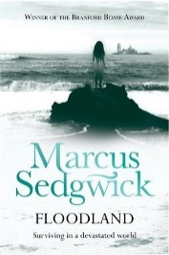  Floodland – Marcus Sedgewick  Climate Change - | Shackleton’s Journey-William Grill  Shakleton’s Journey  Ice Trap | Myths & Legends – Anthony Horowitz  Fantastic beasts and where to find them. | 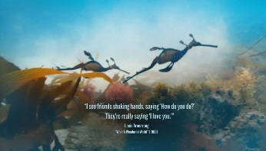  David Attenburgh documentaries  David Attenburgh documentary clips.  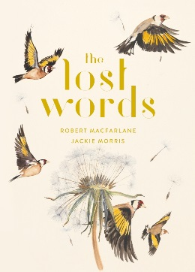  The Lost Words - | 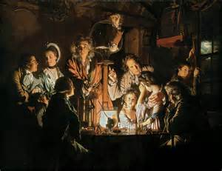  Historical Painting: ‘Bird in a pump’  (Linkung to William Harvey in science)  Book Frankenstein (diff. versions) | Film stimulus
Additional key books to use in reading journey | 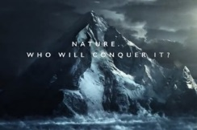  Poem: I am the dreadful menace  Climate Change - Eyewitness  + articles (including newspaper) and other books on Climate change | Survivors- David Long & Kerry Hyndman | 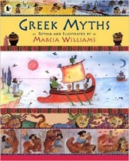  Additional retellings  of Greek Myths  Extracts from Percy Jackson | 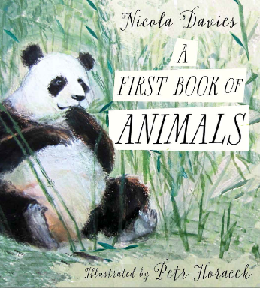  A first book of Animals- poetry book  + Revision of past SAT reading papers & techniques. | Dracula (Adapted version appropriate to age)  & extracts from Pig Heart Boy – Malorie Blackman | Curriculum reading & real life exaples of job adverts, science explanations etc.

