Long Term Overview: The Reading Journey for Year 5 2020-21 Theme Genre Author Cross Curricular
 | Autumn 1  7 weeks | Autumn 2  7 weeks | Spring 1  6 weeks | Spring 2  6 weeks | Summer 1  6 weeks | Summer 2  7 weeks
Theme | Remembrance  World War 1 (History) | Into the Unknown  Earth & Space (Science) | Threats to the Natural World | Survival  The Amazon (Geography) | Peril | Discovery  The Ancient Egyptians (History)
 | Narrative-flashback  Poetry | Narrative: description  Explanatory: Space | Persuasion: speech (plastic)  Page in style of Wonder Garden on Great Barrier Reef- mixed genre | Narrative: adventure (chapter of the book.)  NC report/ recount: fact file including mini biography about the explorer Percy Fawcett & section on Amazon Reainforest | Adventure/ thriller linear-Narrative | Historical narrative- recount of discovery.  Recount: Newspaper article
Writing Journey Text Driver/s: | 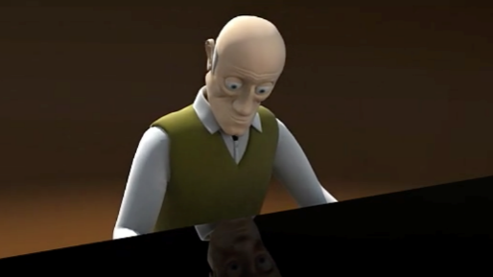  The Piano by Aidan Gibbons  ……………………………………….  War Poems – Flanders Field | 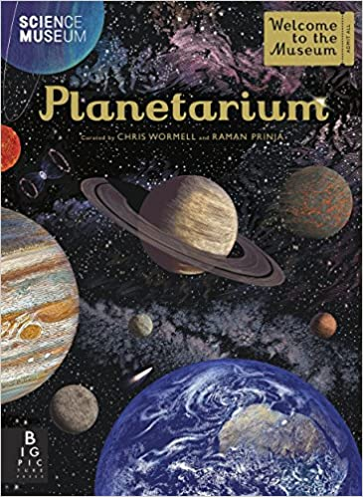  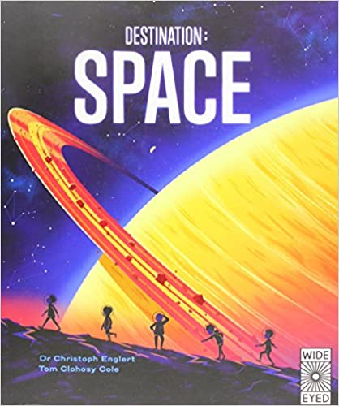  other non fiction texts. | Blue Planet Plastic awareness programme  https://www.youtube.com/watch?v=xLx4fVsYdTI  + Book of Greta Thunberg speeches.  ………………………………….  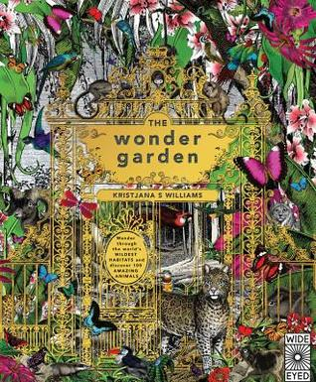  Wonder Garden | The Explorer- Katherine Rundell  ……………………………………….  The Quest for Z: The True Story of Explorer Percy Fawcett and a Lost City in the Amazon  + clips from filmLost Cityof Z | #Jurassic Park –Book & film clips  The Lost World- Arthur Conan Doyle | Egyptology: Search for the Tomb of Osiris (Ology Series).
Additional key books to use in reading journey | 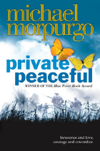  Private Peaceful –Michael Morpurgo  & extracts from other related books.  + War poems | 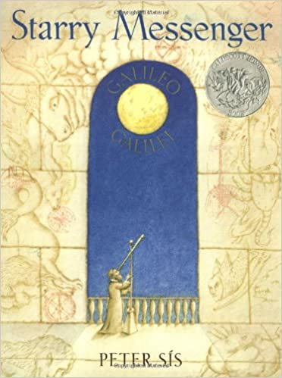  Starry Messenger- Peter Sis | 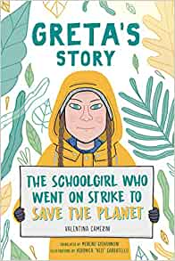  Greta’s Story. The schoolgirl who went on strike to save the plane-  Valentina Camerin  + picture book | Survivors-David Long & Kerry Hyndman | 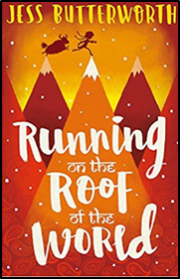  Running on the Roof of the World  Extracts (from Jaws- adapted for age)  + Revision (including non-fiction) | The Story of Tutankhamun  Patricia Cleveland-Peck & Isabel Greenberg  + Non Fiction texts – Ancient Egyptians  & Secrets of a Sun King by Emma Carroll

