Lesson 1 – Living Things  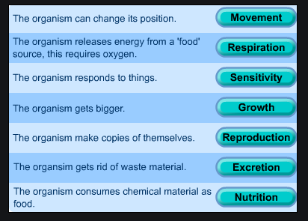 | Lesson 5 – Human impact on the environment  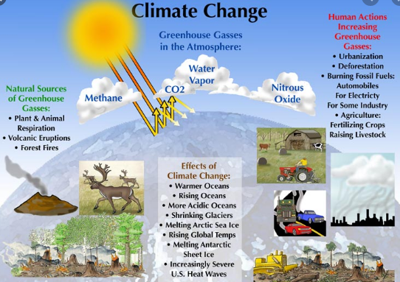
Lesson 3 – Flowering and non-flowering plants  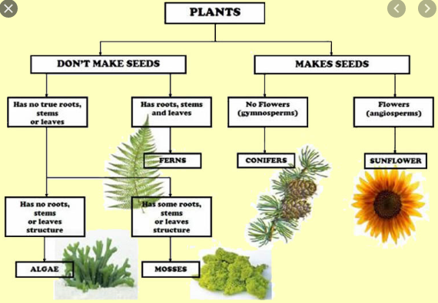 | 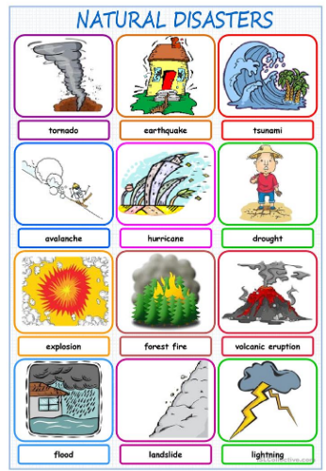  Lesson 4 – Natural disasters | Lesson 2 – Vertebrates and invertebrates